LinkedIn Latest Articles

Published 2 hours ago

**[[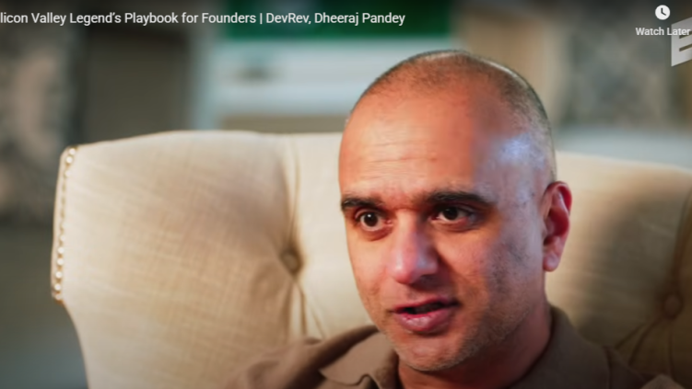](https://www.linkedin.com/pulse/devrev-bridging-developer-customer-gap-reshaping-crm-market-hukkeri-qwegc)](https://www.linkedin.com/pulse/devrev-bridging-developer-customer-gap-reshaping-crm-market-hukkeri-qwegc" \t "_self)**

**[DevRev: Bridging the Developer-Customer Gap and Reshaping the Enterprise CRM Market](https://www.linkedin.com/pulse/devrev-bridging-developer-customer-gap-reshaping-crm-market-hukkeri-qwegc" \t "_self)**

[Girish Hukkeri](https://www.linkedin.com/pulse/devrev-bridging-developer-customer-gap-reshaping-crm-market-hukkeri-qwegc" \t "_self)

* 1

Feed post

Published 11 hours ago

**[[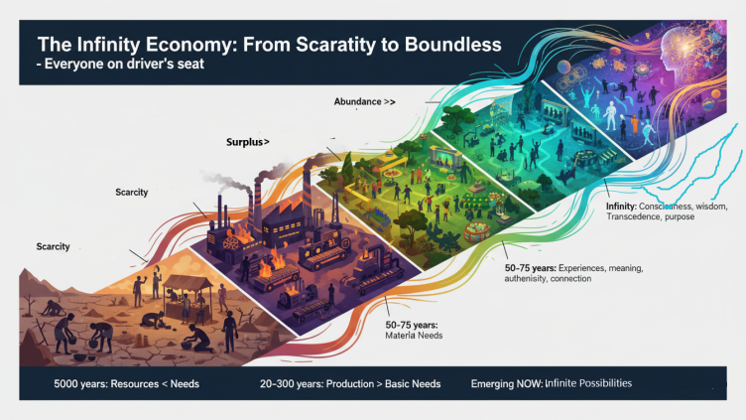](https://www.linkedin.com/pulse/zeroth-principles-extended-series-girish-hukkeri-dgxtc)](https://www.linkedin.com/pulse/zeroth-principles-extended-series-girish-hukkeri-dgxtc" \t "_self)**

**[Zeroth Principles Extended Series](https://www.linkedin.com/pulse/zeroth-principles-extended-series-girish-hukkeri-dgxtc" \t "_self)**

[Girish Hukkeri](https://www.linkedin.com/pulse/zeroth-principles-extended-series-girish-hukkeri-dgxtc" \t "_self)

* 4Munir Machmud Ali and 3 others

Feed post

Published 1 day ago

**[[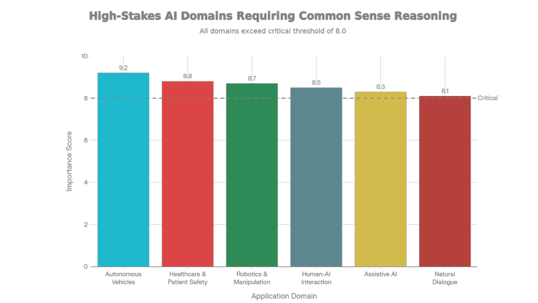](https://www.linkedin.com/pulse/seven-year-old-test-building-artificial-common-sense-general-hukkeri-vfpac)](https://www.linkedin.com/pulse/seven-year-old-test-building-artificial-common-sense-general-hukkeri-vfpac" \t "_self)**

**[The Seven-Year-Old Test: Building Artificial Common Sense as the Foundation for General Intelligence](https://www.linkedin.com/pulse/seven-year-old-test-building-artificial-common-sense-general-hukkeri-vfpac" \t "_self)**

[Girish Hukkeri](https://www.linkedin.com/pulse/seven-year-old-test-building-artificial-common-sense-general-hukkeri-vfpac" \t "_self)

* 5Ajijia Diwa and 4 others

Feed post

Published 2 days ago

**[[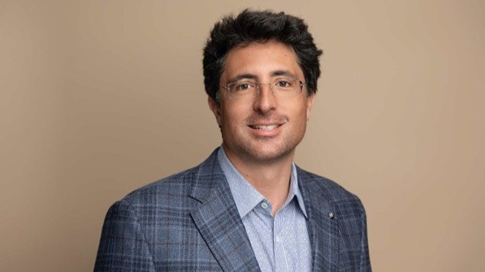](https://www.linkedin.com/pulse/niccolo-de-masi-physicist-ceo-leading-ionqs-quantum-girish-hukkeri-ztezc)](https://www.linkedin.com/pulse/niccolo-de-masi-physicist-ceo-leading-ionqs-quantum-girish-hukkeri-ztezc" \t "_self)**

**[Niccolo de Masi: The Physicist-CEO Leading IonQ's Quantum Revolution](https://www.linkedin.com/pulse/niccolo-de-masi-physicist-ceo-leading-ionqs-quantum-girish-hukkeri-ztezc" \t "_self)**

[Girish Hukkeri](https://www.linkedin.com/pulse/niccolo-de-masi-physicist-ceo-leading-ionqs-quantum-girish-hukkeri-ztezc" \t "_self)

* 10
  + 1 comment

Feed post

Published 2 days ago

**[[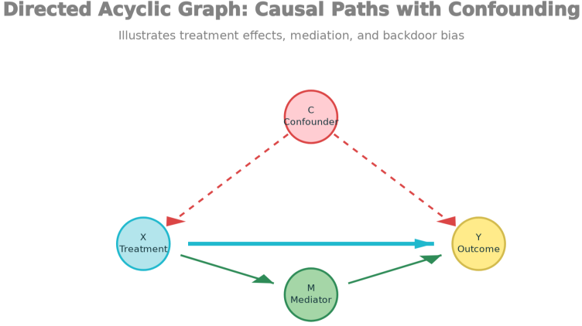](https://www.linkedin.com/pulse/from-prediction-understanding-causal-inference-gateway-girish-hukkeri-5uxnc)](https://www.linkedin.com/pulse/from-prediction-understanding-causal-inference-gateway-girish-hukkeri-5uxnc" \t "_self)**

**[From Prediction to Understanding: Causal Inference as the Gateway to True AI](https://www.linkedin.com/pulse/from-prediction-understanding-causal-inference-gateway-girish-hukkeri-5uxnc" \t "_self)**

[Girish Hukkeri](https://www.linkedin.com/pulse/from-prediction-understanding-causal-inference-gateway-girish-hukkeri-5uxnc" \t "_self)

* 3Mohammed Alomar and 2 others

Feed post

Published 3 days ago

**[[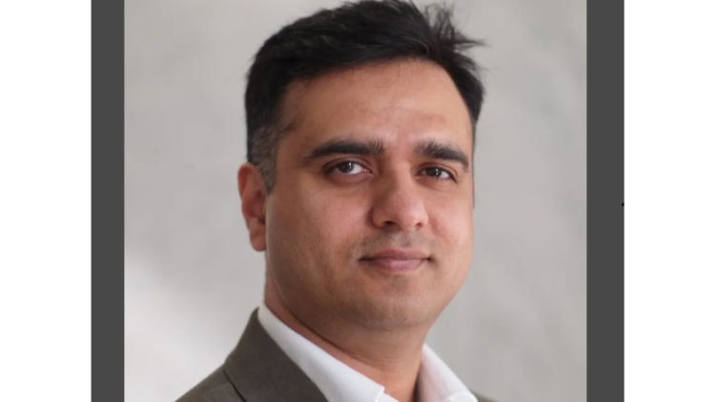](https://www.linkedin.com/pulse/dheeraj-pandey-architect-hybrid-cloud-infrastructure-girish-hukkeri-dlubc)](https://www.linkedin.com/pulse/dheeraj-pandey-architect-hybrid-cloud-infrastructure-girish-hukkeri-dlubc" \t "_self)**

**[Dheeraj Pandey: The Architect of Hybrid Cloud Infrastructure and the Visionary Reshaping Enterprise IT](https://www.linkedin.com/pulse/dheeraj-pandey-architect-hybrid-cloud-infrastructure-girish-hukkeri-dlubc" \t "_self)**

[Girish Hukkeri](https://www.linkedin.com/pulse/dheeraj-pandey-architect-hybrid-cloud-infrastructure-girish-hukkeri-dlubc" \t "_self)

* 8SATISH HUKKERI and 7 others

Feed post

Published 3 days ago

**[[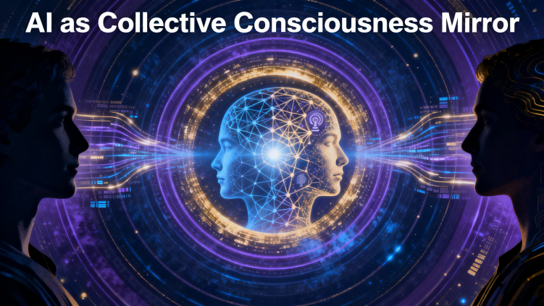](https://www.linkedin.com/pulse/zeroth-principles-part-two-ai-spectacle-humanitys-infinite-hukkeri-u6vrc)](https://www.linkedin.com/pulse/zeroth-principles-part-two-ai-spectacle-humanitys-infinite-hukkeri-u6vrc" \t "_self)**

**[Zeroth Principles - Part Two: AI as Spectacle, Humanity’s Infinite Mirror](https://www.linkedin.com/pulse/zeroth-principles-part-two-ai-spectacle-humanitys-infinite-hukkeri-u6vrc" \t "_self)**

[Girish Hukkeri](https://www.linkedin.com/pulse/zeroth-principles-part-two-ai-spectacle-humanitys-infinite-hukkeri-u6vrc" \t "_self)

* 1
  + 3 comments

Feed post

Published 4 days ago

**[[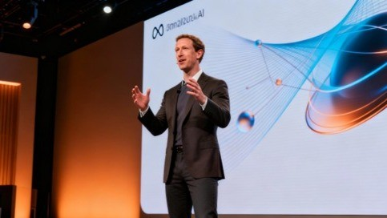](https://www.linkedin.com/pulse/metas-ai-present-future-llama-agi-2025-30-vision-girish-hukkeri-i90je)](https://www.linkedin.com/pulse/metas-ai-present-future-llama-agi-2025-30-vision-girish-hukkeri-i90je" \t "_self)**

**[Meta's AI Present and Future: Llama, AGI, and the 2025-'30 Vision](https://www.linkedin.com/pulse/metas-ai-present-future-llama-agi-2025-30-vision-girish-hukkeri-i90je" \t "_self)**

[Girish Hukkeri](https://www.linkedin.com/pulse/metas-ai-present-future-llama-agi-2025-30-vision-girish-hukkeri-i90je" \t "_self)

* 5Amoni Finau and 4 others
  + 4 comments

Feed post

Published 4 days ago

**[[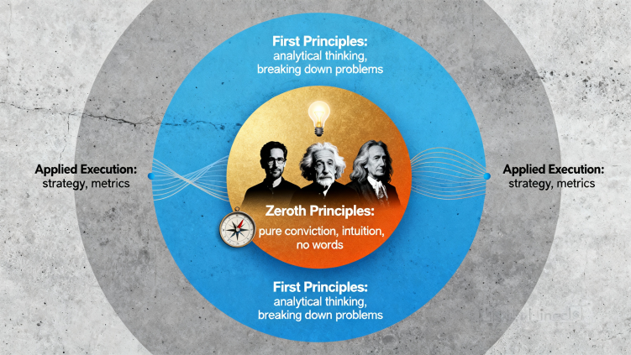](https://www.linkedin.com/pulse/zeroth-principles-part-one-insight-precedes-invention-girish-hukkeri-ugwgc)](https://www.linkedin.com/pulse/zeroth-principles-part-one-insight-precedes-invention-girish-hukkeri-ugwgc" \t "_self)**

**[Zeroth Principles - Part One: The Insight Precedes the Invention](https://www.linkedin.com/pulse/zeroth-principles-part-one-insight-precedes-invention-girish-hukkeri-ugwgc" \t "_self)**

[Girish Hukkeri](https://www.linkedin.com/pulse/zeroth-principles-part-one-insight-precedes-invention-girish-hukkeri-ugwgc" \t "_self)

* 4Ronnie A. Dumaguin and 3 others
  + 14 comments

Feed post

Published 5 days ago

**[[](https://www.linkedin.com/pulse/metas-mobile-revolution-advertising-dominance-2012-18-girish-hukkeri-xrdqe)](https://www.linkedin.com/pulse/metas-mobile-revolution-advertising-dominance-2012-18-girish-hukkeri-xrdqe" \t "_self)**

**[Meta's Mobile Revolution and Advertising Dominance (2012-'18)](https://www.linkedin.com/pulse/metas-mobile-revolution-advertising-dominance-2012-18-girish-hukkeri-xrdqe" \t "_self)**

[Girish Hukkeri](https://www.linkedin.com/pulse/metas-mobile-revolution-advertising-dominance-2012-18-girish-hukkeri-xrdqe" \t "_self)

* 5Singgih Tjahjono and 4 others
  + 2 comments

Feed post

Published 5 days ago

**[[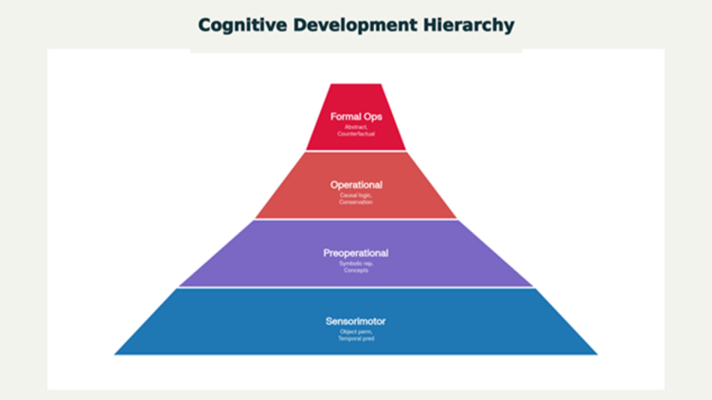](https://www.linkedin.com/pulse/building-artificial-minds-world-models-cognitive-path-girish-hukkeri-fauze)](https://www.linkedin.com/pulse/building-artificial-minds-world-models-cognitive-path-girish-hukkeri-fauze" \t "_self)**

**[Building Artificial Minds: World Models and Cognitive Development as the Path to AGI](https://www.linkedin.com/pulse/building-artificial-minds-world-models-cognitive-path-girish-hukkeri-fauze" \t "_self)**

[Girish Hukkeri](https://www.linkedin.com/pulse/building-artificial-minds-world-models-cognitive-path-girish-hukkeri-fauze" \t "_self)

* 7SATISH HUKKERI and 6 others
  + 2 comments

Feed post

Published 6 days ago

**[[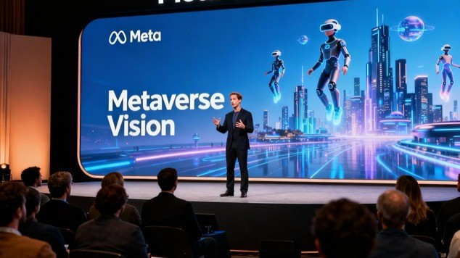](https://www.linkedin.com/pulse/metas-metaverse-pivot-reality-labs-investment-2019-23-girish-hukkeri-gsyae)](https://www.linkedin.com/pulse/metas-metaverse-pivot-reality-labs-investment-2019-23-girish-hukkeri-gsyae" \t "_self)**

**[Meta's Metaverse Pivot and Reality Labs Investment (2019-'23)](https://www.linkedin.com/pulse/metas-metaverse-pivot-reality-labs-investment-2019-23-girish-hukkeri-gsyae" \t "_self)**

[Girish Hukkeri](https://www.linkedin.com/pulse/metas-metaverse-pivot-reality-labs-investment-2019-23-girish-hukkeri-gsyae" \t "_self)

* 1

Feed post

Published 6 days ago

**[[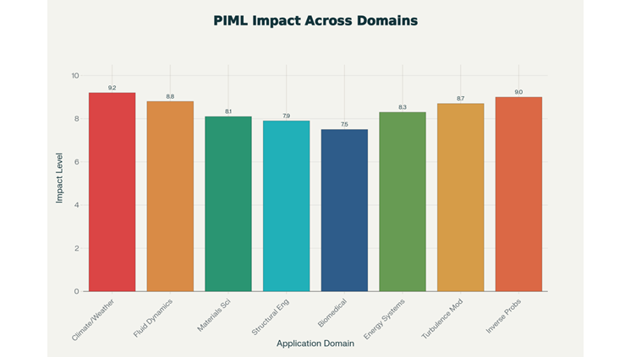](https://www.linkedin.com/pulse/physics-informed-machine-learning-embedding-laws-nature-hukkeri-ceqke)](https://www.linkedin.com/pulse/physics-informed-machine-learning-embedding-laws-nature-hukkeri-ceqke" \t "_self)**

**[Physics-Informed Machine Learning: Embedding the Laws of Nature into AI](https://www.linkedin.com/pulse/physics-informed-machine-learning-embedding-laws-nature-hukkeri-ceqke" \t "_self)**

[Girish Hukkeri](https://www.linkedin.com/pulse/physics-informed-machine-learning-embedding-laws-nature-hukkeri-ceqke" \t "_self)

* 2Singgih Tjahjono and 1 other

Feed post

Published 1 week ago

**[[](https://www.linkedin.com/pulse/metas-genesis-from-harvard-dorm-social-media-empire-girish-hukkeri-hwdae)](https://www.linkedin.com/pulse/metas-genesis-from-harvard-dorm-social-media-empire-girish-hukkeri-hwdae" \t "_self)**

**[Meta's Genesis: From Harvard Dorm to Social Media Empire (2004-2012)](https://www.linkedin.com/pulse/metas-genesis-from-harvard-dorm-social-media-empire-girish-hukkeri-hwdae" \t "_self)**

[Girish Hukkeri](https://www.linkedin.com/pulse/metas-genesis-from-harvard-dorm-social-media-empire-girish-hukkeri-hwdae" \t "_self)

Feed post

Published 1 week ago

**[[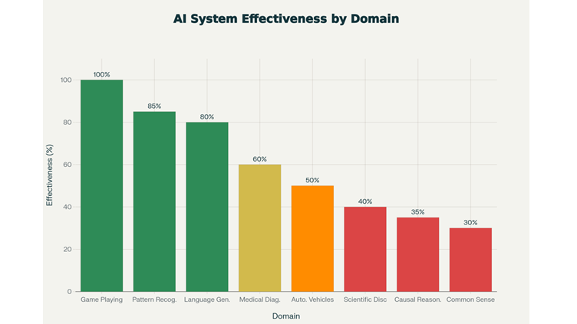](https://www.linkedin.com/pulse/ai-spring-lingering-winter-beyond-pattern-recognition-girish-hukkeri-61gze)](https://www.linkedin.com/pulse/ai-spring-lingering-winter-beyond-pattern-recognition-girish-hukkeri-61gze" \t "_self)**

**[The AI Spring and the Lingering Winter: Beyond Pattern Recognition to Understanding Unknown Laws](https://www.linkedin.com/pulse/ai-spring-lingering-winter-beyond-pattern-recognition-girish-hukkeri-61gze" \t "_self)**

[Girish Hukkeri](https://www.linkedin.com/pulse/ai-spring-lingering-winter-beyond-pattern-recognition-girish-hukkeri-61gze" \t "_self)

* 7Pavan Goyal and 6 others
  + 1 comment

Feed post

Published 1 week ago

**[[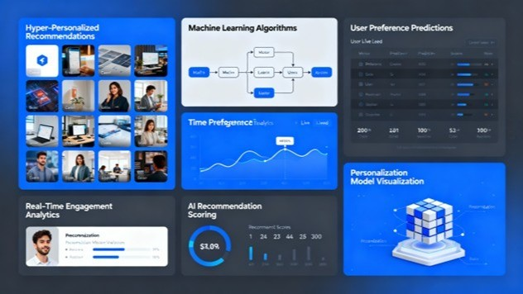](https://www.linkedin.com/pulse/entertainment-ai-era-generative-content-future-models-girish-hukkeri-ioxee)](https://www.linkedin.com/pulse/entertainment-ai-era-generative-content-future-models-girish-hukkeri-ioxee" \t "_self)**

**[Entertainment in the AI Era: Generative Content, Personalization, and Future Models (2025-'30)](https://www.linkedin.com/pulse/entertainment-ai-era-generative-content-future-models-girish-hukkeri-ioxee" \t "_self)**

[Girish Hukkeri](https://www.linkedin.com/pulse/entertainment-ai-era-generative-content-future-models-girish-hukkeri-ioxee" \t "_self)

* 9Rishi Raj Kishore and 8 others
  + 4 comments

Feed post

Published 1 week ago

**[[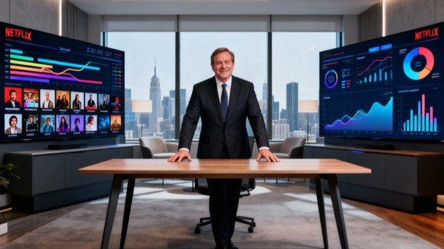](https://www.linkedin.com/pulse/streaming-wars-password-sharing-crackdown-focus-girish-hukkeri-eoq7e)](https://www.linkedin.com/pulse/streaming-wars-password-sharing-crackdown-focus-girish-hukkeri-eoq7e" \t "_self)**

**[Streaming Wars, Password Sharing Crackdown, and Profitability Focus (2015-2025)](https://www.linkedin.com/pulse/streaming-wars-password-sharing-crackdown-focus-girish-hukkeri-eoq7e" \t "_self)**

[Girish Hukkeri](https://www.linkedin.com/pulse/streaming-wars-password-sharing-crackdown-focus-girish-hukkeri-eoq7e" \t "_self)

* 2Ronnie A. Dumaguin and 1 other

Feed post

Published 1 week ago

**[[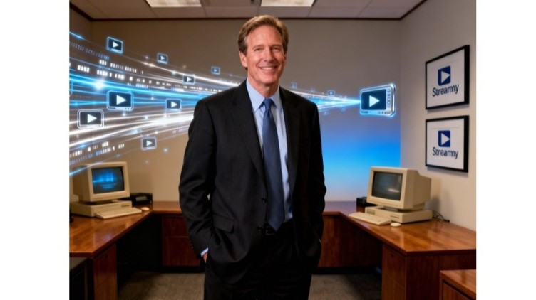](https://www.linkedin.com/pulse/netflix-origins-dvd-disruption-1997-2005-girish-hukkeri-v90xe)](https://www.linkedin.com/pulse/netflix-origins-dvd-disruption-1997-2005-girish-hukkeri-v90xe" \t "_self)**

**[Netflix Origins and DVD Disruption (1997-2005)](https://www.linkedin.com/pulse/netflix-origins-dvd-disruption-1997-2005-girish-hukkeri-v90xe" \t "_self)**

[Girish Hukkeri](https://www.linkedin.com/pulse/netflix-origins-dvd-disruption-1997-2005-girish-hukkeri-v90xe" \t "_self)

* 3Kaushik Naarayan and 2 others
  + 1 comment

Feed post

Published 1 week ago

**[[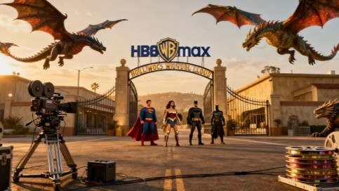](https://www.linkedin.com/pulse/netflix-acquires-warner-bros-discovery-entertainment-industry-girish-7as0e)](https://www.linkedin.com/pulse/netflix-acquires-warner-bros-discovery-entertainment-industry-girish-7as0e" \t "_self)**

**[Netflix Acquires Warner Bros. Discovery: The Entertainment Industry Consolidation Catalyst (December 2025)](https://www.linkedin.com/pulse/netflix-acquires-warner-bros-discovery-entertainment-industry-girish-7as0e" \t "_self)**

[Girish Hukkeri](https://www.linkedin.com/pulse/netflix-acquires-warner-bros-discovery-entertainment-industry-girish-7as0e" \t "_self)

* 6
  + 2 comments

Feed post

Published 1 week ago

**[[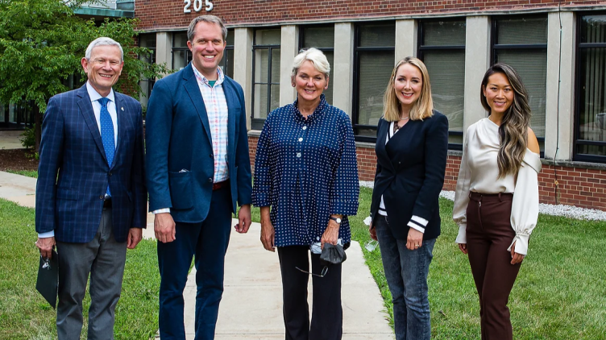](https://www.linkedin.com/pulse/jacob-dewitte-caroline-cochran-building-nuclear-through-hukkeri-0aoye)](https://www.linkedin.com/pulse/jacob-dewitte-caroline-cochran-building-nuclear-through-hukkeri-0aoye" \t "_self)**

**[Jacob DeWitte & Caroline Cochran: Building the Nuclear Renaissance Through Oklo Inc.](https://www.linkedin.com/pulse/jacob-dewitte-caroline-cochran-building-nuclear-through-hukkeri-0aoye" \t "_self)**

[Girish Hukkeri](https://www.linkedin.com/pulse/jacob-dewitte-caroline-cochran-building-nuclear-through-hukkeri-0aoye" \t "_self)

* 4Trevor Dawson and 3 others
  + 4 comments

Feed post

Published 1 week ago

**[[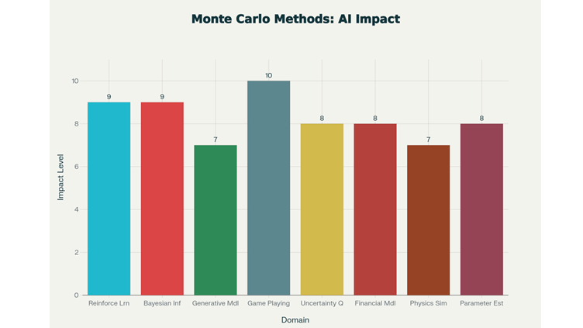](https://www.linkedin.com/pulse/monte-carlo-simulation-its-impact-ai-girish-hukkeri-5ca4e)](https://www.linkedin.com/pulse/monte-carlo-simulation-its-impact-ai-girish-hukkeri-5ca4e" \t "_self)**

**[Monte Carlo Simulation and Its Impact on AI](https://www.linkedin.com/pulse/monte-carlo-simulation-its-impact-ai-girish-hukkeri-5ca4e" \t "_self)**

[Girish Hukkeri](https://www.linkedin.com/pulse/monte-carlo-simulation-its-impact-ai-girish-hukkeri-5ca4e" \t "_self)

* 8Shubham Kumar and 7 others
  + 1 comment

Feed post

Published 1 week ago

**[[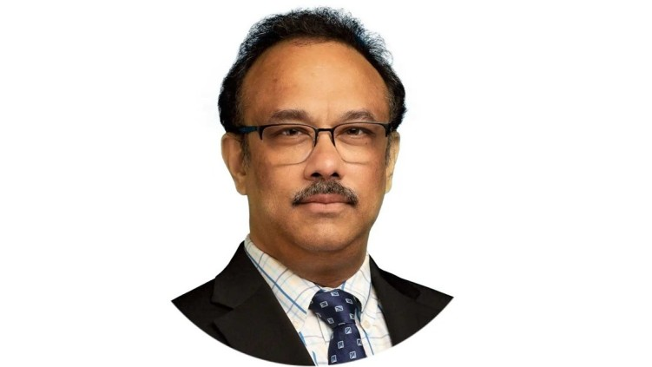](https://www.linkedin.com/pulse/rajeeb-raj-hazra-architect-behind-quantinuums-quantum-girish-hukkeri-ovqke)](https://www.linkedin.com/pulse/rajeeb-raj-hazra-architect-behind-quantinuums-quantum-girish-hukkeri-ovqke" \t "_self)**

**[Rajeeb (Raj) Hazra: The Architect Behind Quantinuum's Quantum Revolution](https://www.linkedin.com/pulse/rajeeb-raj-hazra-architect-behind-quantinuums-quantum-girish-hukkeri-ovqke" \t "_self)**

[Girish Hukkeri](https://www.linkedin.com/pulse/rajeeb-raj-hazra-architect-behind-quantinuums-quantum-girish-hukkeri-ovqke" \t "_self)

* 4Ronnie A. Dumaguin and 3 others
  + 1 comment

Feed post

Published 1 week ago

**[[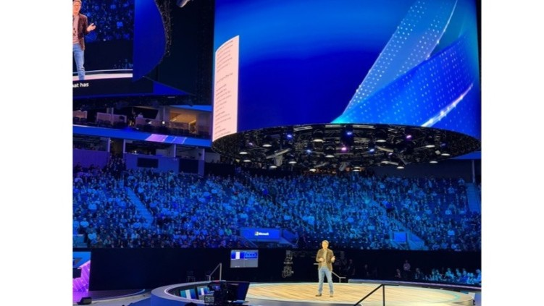](https://www.linkedin.com/pulse/microsofts-ai-future-copilot-integration-quantum-path-girish-hukkeri-sh3pe)](https://www.linkedin.com/pulse/microsofts-ai-future-copilot-integration-quantum-path-girish-hukkeri-sh3pe" \t "_self)**

**[Microsoft's AI Future: Copilot Integration, Quantum Computing, AI Infrastructure, and Path to AGI (2025-2035)](https://www.linkedin.com/pulse/microsofts-ai-future-copilot-integration-quantum-path-girish-hukkeri-sh3pe" \t "_self)**

[Girish Hukkeri](https://www.linkedin.com/pulse/microsofts-ai-future-copilot-integration-quantum-path-girish-hukkeri-sh3pe" \t "_self)

* 2Ronnie A. Dumaguin and 1 other

Feed post

Published 1 week ago

**[[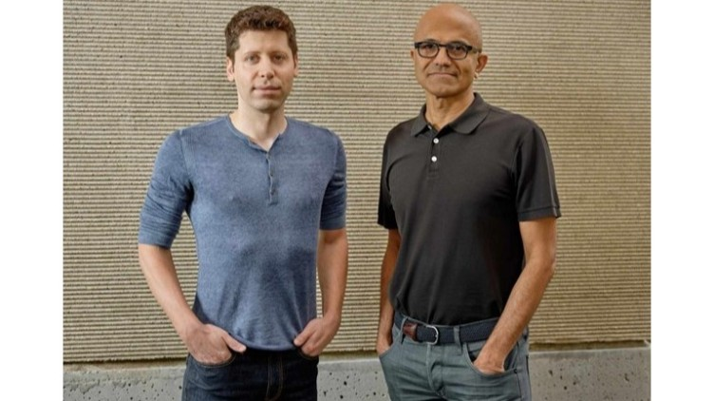](https://www.linkedin.com/pulse/satya-nadella-era-part-2-from-cloud-leader-ai-girish-hukkeri-afv5e)](https://www.linkedin.com/pulse/satya-nadella-era-part-2-from-cloud-leader-ai-girish-hukkeri-afv5e" \t "_self)**

**[Satya Nadella Era Part 2: From Cloud Leader to AI Powerhouse (2017-2025)](https://www.linkedin.com/pulse/satya-nadella-era-part-2-from-cloud-leader-ai-girish-hukkeri-afv5e" \t "_self)**

[Girish Hukkeri](https://www.linkedin.com/pulse/satya-nadella-era-part-2-from-cloud-leader-ai-girish-hukkeri-afv5e" \t "_self)

* 10Fawaz AbdulQader and 9 others
  + 4 comments

Feed post

Published 1 week ago

**[[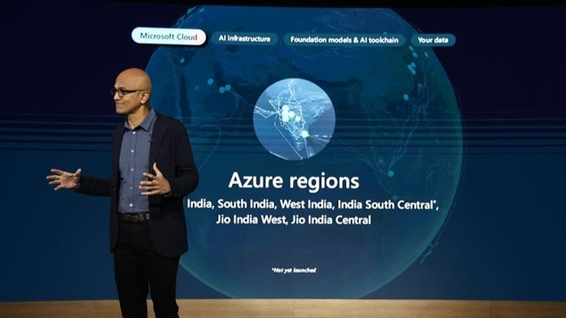](https://www.linkedin.com/pulse/satya-nadella-era-part-1-transformation-begins-girish-hukkeri-geoce)](https://www.linkedin.com/pulse/satya-nadella-era-part-1-transformation-begins-girish-hukkeri-geoce" \t "_self)**

**[Satya Nadella Era Part 1: The Transformation Begins (2014-2017)](https://www.linkedin.com/pulse/satya-nadella-era-part-1-transformation-begins-girish-hukkeri-geoce" \t "_self)**

[Girish Hukkeri](https://www.linkedin.com/pulse/satya-nadella-era-part-1-transformation-begins-girish-hukkeri-geoce" \t "_self)

* 6Ronnie A. Dumaguin and 5 others
  + 1 comment

Feed post

Published 1 week ago

**[[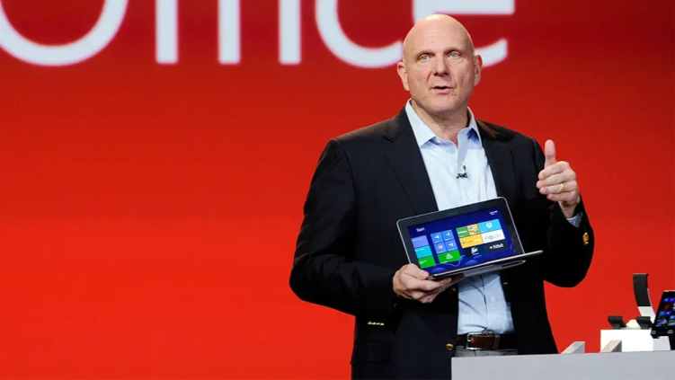](https://www.linkedin.com/pulse/steve-ballmer-interim-leadership-era-from-cloud-girish-hukkeri-jozne)](https://www.linkedin.com/pulse/steve-ballmer-interim-leadership-era-from-cloud-girish-hukkeri-jozne" \t "_self)**

**[The Steve Ballmer and Interim Leadership Era: From Consolidation to Cloud Skepticism (2000-2013)](https://www.linkedin.com/pulse/steve-ballmer-interim-leadership-era-from-cloud-girish-hukkeri-jozne" \t "_self)**

[Girish Hukkeri](https://www.linkedin.com/pulse/steve-ballmer-interim-leadership-era-from-cloud-girish-hukkeri-jozne" \t "_self)

* 1

Feed post

Published 1 week ago

**[[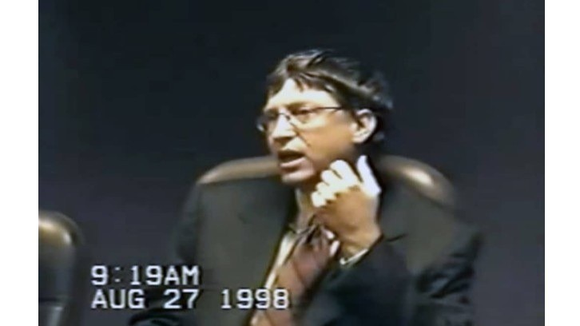](https://www.linkedin.com/pulse/bill-gates-era-part-3-antitrust-cloud-ambitions-girish-hukkeri-jydke)](https://www.linkedin.com/pulse/bill-gates-era-part-3-antitrust-cloud-ambitions-girish-hukkeri-jydke" \t "_self)**

**[The Bill Gates Era Part 3: Antitrust, Cloud Ambitions, and Gates' Transition (2000-2006)](https://www.linkedin.com/pulse/bill-gates-era-part-3-antitrust-cloud-ambitions-girish-hukkeri-jydke" \t "_self)**

[Girish Hukkeri](https://www.linkedin.com/pulse/bill-gates-era-part-3-antitrust-cloud-ambitions-girish-hukkeri-jydke" \t "_self)

* 3Singgih Tjahjono and 2 others

Feed post

Published 2 weeks ago

**[[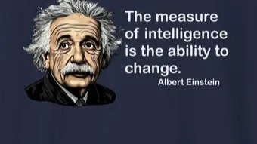](https://www.linkedin.com/pulse/einstein-measure-intelligence-ability-change-girish-hukkeri-4asae)](https://www.linkedin.com/pulse/einstein-measure-intelligence-ability-change-girish-hukkeri-4asae" \t "_self)**

**[Einstein: The Measure of Intelligence - The Ability to Change](https://www.linkedin.com/pulse/einstein-measure-intelligence-ability-change-girish-hukkeri-4asae" \t "_self)**

[Girish Hukkeri](https://www.linkedin.com/pulse/einstein-measure-intelligence-ability-change-girish-hukkeri-4asae" \t "_self)

* 4Fawaz AbdulQader and 3 others
  + 1 comment

Feed post

Published 2 weeks ago

**[[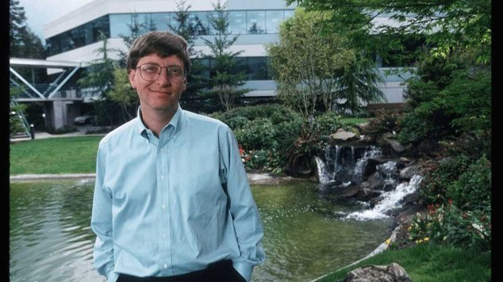](https://www.linkedin.com/pulse/bill-gates-era-part-2-windows-dominance-personal-girish-hukkeri-jmane)](https://www.linkedin.com/pulse/bill-gates-era-part-2-windows-dominance-personal-girish-hukkeri-jmane" \t "_self)**

**[The Bill Gates Era Part 2: Windows Dominance and Personal Computing Revolution (1990-2000)](https://www.linkedin.com/pulse/bill-gates-era-part-2-windows-dominance-personal-girish-hukkeri-jmane" \t "_self)**

[Girish Hukkeri](https://www.linkedin.com/pulse/bill-gates-era-part-2-windows-dominance-personal-girish-hukkeri-jmane" \t "_self)

* 7Ajay Babbar and 6 others
  + 2 comments

Feed post

Published 2 weeks ago

**[[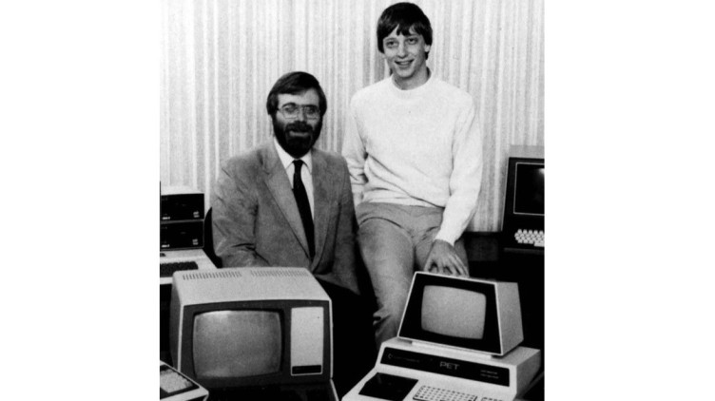](https://www.linkedin.com/pulse/bill-gates-era-part-1-from-garage-monopoly-1975-1990-girish-hukkeri-klvde)](https://www.linkedin.com/pulse/bill-gates-era-part-1-from-garage-monopoly-1975-1990-girish-hukkeri-klvde" \t "_self)**

**[The Bill Gates Era Part 1: From Garage to Monopoly (1975-1990)](https://www.linkedin.com/pulse/bill-gates-era-part-1-from-garage-monopoly-1975-1990-girish-hukkeri-klvde" \t "_self)**

[Girish Hukkeri](https://www.linkedin.com/pulse/bill-gates-era-part-1-from-garage-monopoly-1975-1990-girish-hukkeri-klvde" \t "_self)

* 6Bharat Shree Maheshwari and 5 others

Feed post

Published 2 weeks ago

**[[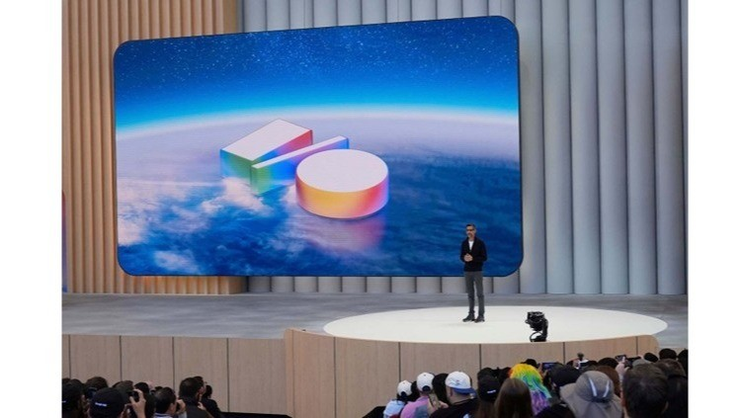](https://www.linkedin.com/pulse/alphabets-ai-future-investments-initiatives-path-agi-beyond-hukkeri-m2pre)](https://www.linkedin.com/pulse/alphabets-ai-future-investments-initiatives-path-agi-beyond-hukkeri-m2pre" \t "_self)**

**[Alphabet's AI Future: Investments, Initiatives, and the Path to AGI and Beyond (2024-2030)](https://www.linkedin.com/pulse/alphabets-ai-future-investments-initiatives-path-agi-beyond-hukkeri-m2pre" \t "_self)**

[Girish Hukkeri](https://www.linkedin.com/pulse/alphabets-ai-future-investments-initiatives-path-agi-beyond-hukkeri-m2pre" \t "_self)

* 7Singgih Tjahjono and 6 others
  + 5 comments

Feed post

Published 2 weeks ago

**[[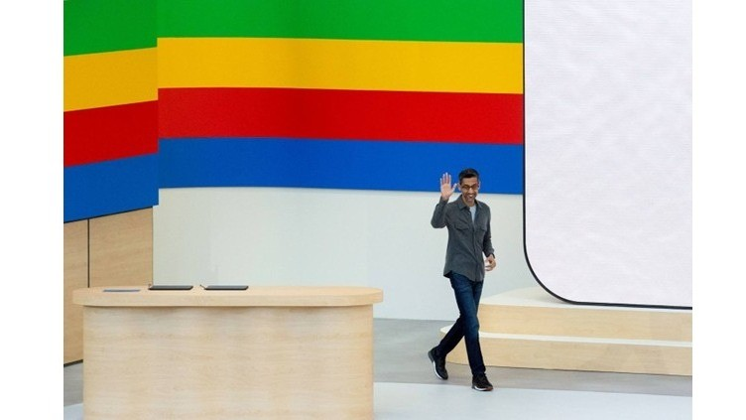](https://www.linkedin.com/pulse/chatgpt-wake-up-call-googles-response-openai-ai-arms-race-hukkeri-m6mye)](https://www.linkedin.com/pulse/chatgpt-wake-up-call-googles-response-openai-ai-arms-race-hukkeri-m6mye" \t "_self)**

**[The ChatGPT Wake-Up Call: Google's Response to OpenAI and the AI Arms Race (2017–2025)](https://www.linkedin.com/pulse/chatgpt-wake-up-call-googles-response-openai-ai-arms-race-hukkeri-m6mye" \t "_self)**

[Girish Hukkeri](https://www.linkedin.com/pulse/chatgpt-wake-up-call-googles-response-openai-ai-arms-race-hukkeri-m6mye" \t "_self)

* 3Ganesh Seshan and 2 others

Feed post

Published 2 weeks ago

**[[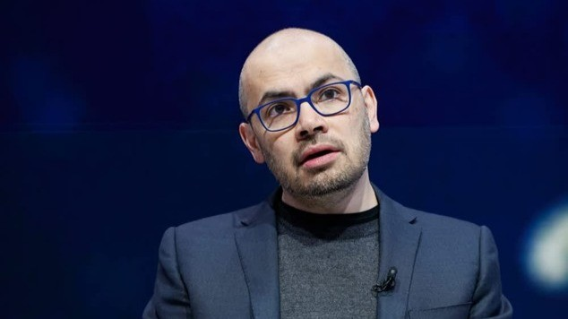](https://www.linkedin.com/pulse/deepmind-acquisition-early-ai-initiatives-googles-pivot-hukkeri-sdaxe)](https://www.linkedin.com/pulse/deepmind-acquisition-early-ai-initiatives-googles-pivot-hukkeri-sdaxe" \t "_self)**

**[The DeepMind Acquisition and Early AI Initiatives: Google's Pivot to Artificial Intelligence (2011–2017)](https://www.linkedin.com/pulse/deepmind-acquisition-early-ai-initiatives-googles-pivot-hukkeri-sdaxe" \t "_self)**

[Girish Hukkeri](https://www.linkedin.com/pulse/deepmind-acquisition-early-ai-initiatives-googles-pivot-hukkeri-sdaxe" \t "_self)

* 5Trevor Dawson and 4 others

Feed post

Published 2 weeks ago

**[[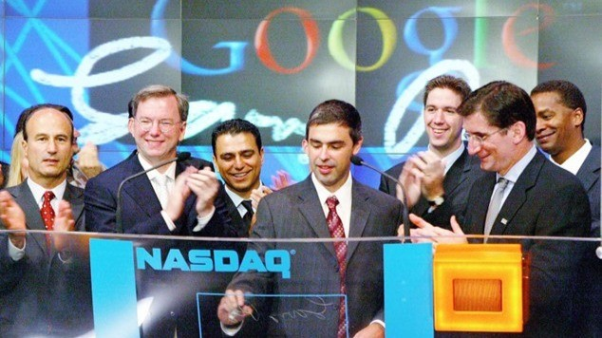](https://www.linkedin.com/pulse/establishing-leadership-googles-expansion-product-20042014-hukkeri-yncxe)](https://www.linkedin.com/pulse/establishing-leadership-googles-expansion-product-20042014-hukkeri-yncxe" \t "_self)**

**[Establishing Leadership: Google's Expansion and Product Ecosystem Dominance (2004–2014)](https://www.linkedin.com/pulse/establishing-leadership-googles-expansion-product-20042014-hukkeri-yncxe" \t "_self)**

[Girish Hukkeri](https://www.linkedin.com/pulse/establishing-leadership-googles-expansion-product-20042014-hukkeri-yncxe" \t "_self)

* 1

Feed post

Published 2 weeks ago

**[[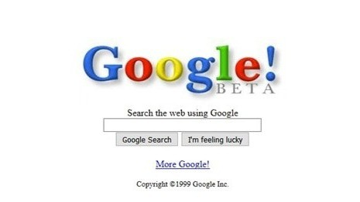](https://www.linkedin.com/pulse/google-genesis-backrub-project-search-engine-19962004-girish-hukkeri-mlfje)](https://www.linkedin.com/pulse/google-genesis-backrub-project-search-engine-19962004-girish-hukkeri-mlfje" \t "_self)**

**[Google Genesis: The BackRub Project to Search Engine Supremacy (1996–2004)](https://www.linkedin.com/pulse/google-genesis-backrub-project-search-engine-19962004-girish-hukkeri-mlfje" \t "_self)**

[Girish Hukkeri](https://www.linkedin.com/pulse/google-genesis-backrub-project-search-engine-19962004-girish-hukkeri-mlfje" \t "_self)

* 6Pavan Goyal and 5 others

Feed post

Published 2 weeks ago

**[[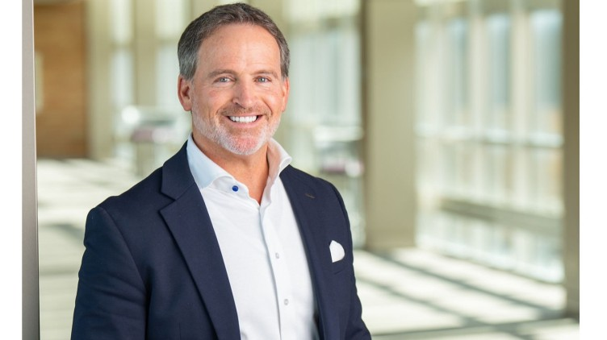](https://www.linkedin.com/pulse/bryan-hanson-solventum-architecting-healthcare-from-3m-girish-hukkeri-hkt9e)](https://www.linkedin.com/pulse/bryan-hanson-solventum-architecting-healthcare-from-3m-girish-hukkeri-hkt9e" \t "_self)**

**[Bryan Hanson & Solventum: Architecting Healthcare Independence from the 3M Legacy](https://www.linkedin.com/pulse/bryan-hanson-solventum-architecting-healthcare-from-3m-girish-hukkeri-hkt9e" \t "_self)**

[Girish Hukkeri](https://www.linkedin.com/pulse/bryan-hanson-solventum-architecting-healthcare-from-3m-girish-hukkeri-hkt9e" \t "_self)

* 6Pavan Goyal and 5 others
  + 1 comment

Feed post

Published 2 weeks ago

**[[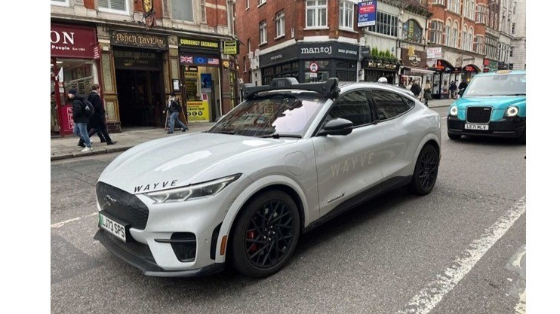](https://www.linkedin.com/pulse/alex-kendall-visionary-redefining-autonomous-mobility-girish-hukkeri-tt5ve)](https://www.linkedin.com/pulse/alex-kendall-visionary-redefining-autonomous-mobility-girish-hukkeri-tt5ve" \t "_self)**

**[Alex Kendall: The Visionary Redefining Autonomous Mobility with Embodied Intelligence](https://www.linkedin.com/pulse/alex-kendall-visionary-redefining-autonomous-mobility-girish-hukkeri-tt5ve" \t "_self)**

[Girish Hukkeri](https://www.linkedin.com/pulse/alex-kendall-visionary-redefining-autonomous-mobility-girish-hukkeri-tt5ve" \t "_self)

* 4Ajijia Diwa and 3 others
  + 1 comment

Feed post

Published 2 weeks ago

**[[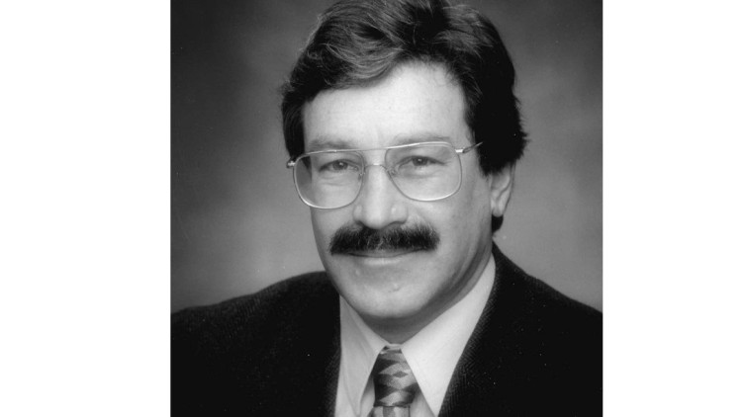](https://www.linkedin.com/pulse/rick-klausner-polymath-pioneer-transforming-cancer-cellular-hukkeri-tur7e)](https://www.linkedin.com/pulse/rick-klausner-polymath-pioneer-transforming-cancer-cellular-hukkeri-tur7e" \t "_self)**

**[Rick Klausner: The Polymath Pioneer Transforming Cancer Detection and Cellular Medicine](https://www.linkedin.com/pulse/rick-klausner-polymath-pioneer-transforming-cancer-cellular-hukkeri-tur7e" \t "_self)**

[Girish Hukkeri](https://www.linkedin.com/pulse/rick-klausner-polymath-pioneer-transforming-cancer-cellular-hukkeri-tur7e" \t "_self)

* 5Hrishikesh Hukkeri and 4 others
  + 1 comment

Feed post

Published 2 weeks ago

**[[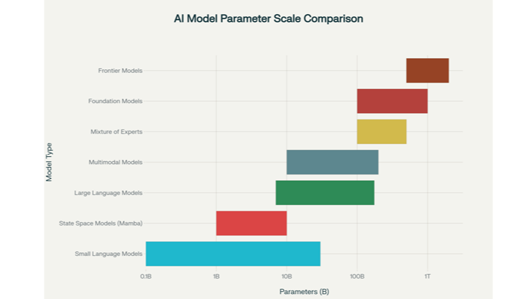](https://www.linkedin.com/pulse/evolution-ai-models-understanding-foundation-frontier-girish-hukkeri-mnp8f)](https://www.linkedin.com/pulse/evolution-ai-models-understanding-foundation-frontier-girish-hukkeri-mnp8f" \t "_self)**

**[The Evolution of AI Models: Understanding Foundation, Frontier, and Emerging Architectures](https://www.linkedin.com/pulse/evolution-ai-models-understanding-foundation-frontier-girish-hukkeri-mnp8f" \t "_self)**

[Girish Hukkeri](https://www.linkedin.com/pulse/evolution-ai-models-understanding-foundation-frontier-girish-hukkeri-mnp8f" \t "_self)

* 3Ajijia Diwa and 2 others

Feed post

Published 2 weeks ago

**[[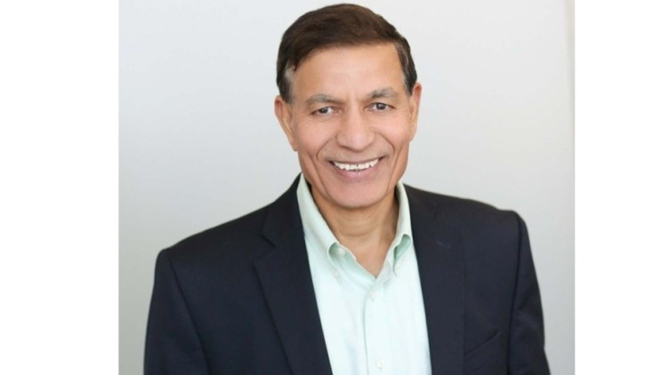](https://www.linkedin.com/pulse/jay-chaudhry-architect-zero-trust-security-girish-hukkeri-ppcue)](https://www.linkedin.com/pulse/jay-chaudhry-architect-zero-trust-security-girish-hukkeri-ppcue" \t "_self)**

**[Jay Chaudhry: The Architect of Zero Trust Security](https://www.linkedin.com/pulse/jay-chaudhry-architect-zero-trust-security-girish-hukkeri-ppcue" \t "_self)**

[Girish Hukkeri](https://www.linkedin.com/pulse/jay-chaudhry-architect-zero-trust-security-girish-hukkeri-ppcue" \t "_self)

* 5
  + 1 comment

Feed post

Published 2 weeks ago

**[[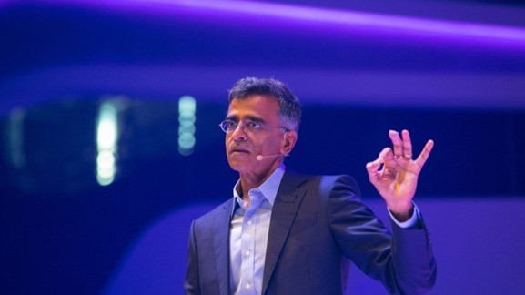](https://www.linkedin.com/pulse/sridhar-ramaswamy-data-visionary-transforming-ai-girish-hukkeri-mskbe)](https://www.linkedin.com/pulse/sridhar-ramaswamy-data-visionary-transforming-ai-girish-hukkeri-mskbe" \t "_self)**

**[Sridhar Ramaswamy: The Data Visionary Transforming Enterprise AI at Snowflake](https://www.linkedin.com/pulse/sridhar-ramaswamy-data-visionary-transforming-ai-girish-hukkeri-mskbe" \t "_self)**

[Girish Hukkeri](https://www.linkedin.com/pulse/sridhar-ramaswamy-data-visionary-transforming-ai-girish-hukkeri-mskbe" \t "_self)

* 7
  + 2 comments

Feed post

Published 3 weeks ago

**[[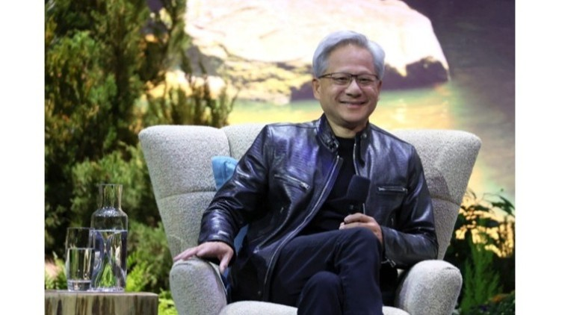](https://www.linkedin.com/pulse/jensen-huang-beyond-nvidia-ai-investments-vision-physical-hukkeri-2uule)](https://www.linkedin.com/pulse/jensen-huang-beyond-nvidia-ai-investments-vision-physical-hukkeri-2uule" \t "_self)**

**[Jensen Huang Beyond Nvidia: AI Investments, Philanthropy, and the Vision for Physical AI and Human-Digital Workforces](https://www.linkedin.com/pulse/jensen-huang-beyond-nvidia-ai-investments-vision-physical-hukkeri-2uule" \t "_self)**

[Girish Hukkeri](https://www.linkedin.com/pulse/jensen-huang-beyond-nvidia-ai-investments-vision-physical-hukkeri-2uule" \t "_self)

* 6Hrishikesh Hukkeri and 5 others

Feed post

Published 3 weeks ago

**[[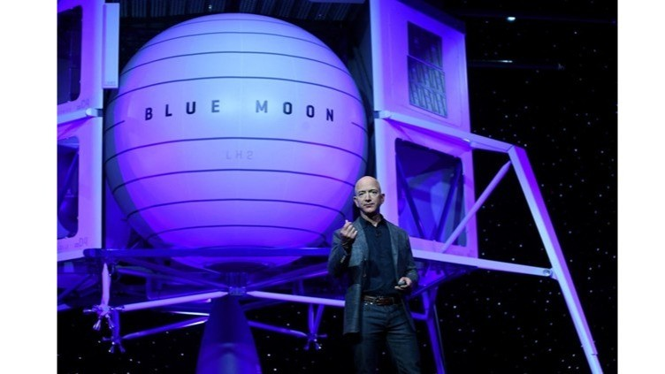](https://www.linkedin.com/pulse/jeff-bezos-ai-empire-from-expeditions-project-girish-hukkeri-ugf3e)](https://www.linkedin.com/pulse/jeff-bezos-ai-empire-from-expeditions-project-girish-hukkeri-ugf3e" \t "_self)**

**[Jeff Bezos' AI Empire: From Bezos Expeditions to Project Prometheus](https://www.linkedin.com/pulse/jeff-bezos-ai-empire-from-expeditions-project-girish-hukkeri-ugf3e" \t "_self)**

[Girish Hukkeri](https://www.linkedin.com/pulse/jeff-bezos-ai-empire-from-expeditions-project-girish-hukkeri-ugf3e" \t "_self)

* 7Kaushik Naarayan and 6 others
  + 1 comment

Feed post

Published 3 weeks ago

**[[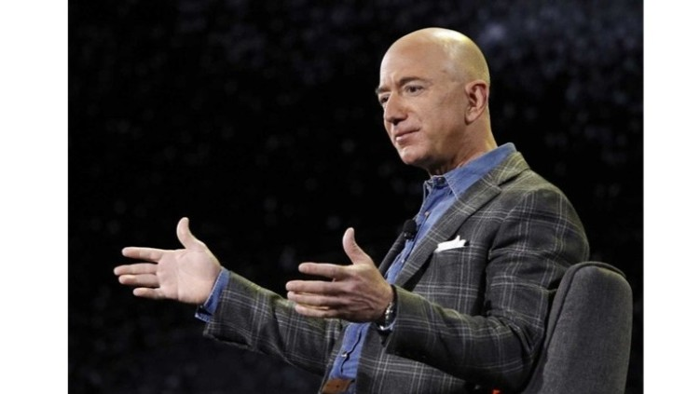](https://www.linkedin.com/pulse/bezos-executive-chairman-vision-next-era-2021present-girish-hukkeri-fjone)](https://www.linkedin.com/pulse/bezos-executive-chairman-vision-next-era-2021present-girish-hukkeri-fjone" \t "_self)**

**[Bezos as Executive Chairman and the Vision for the Next Era (2021-Present)](https://www.linkedin.com/pulse/bezos-executive-chairman-vision-next-era-2021present-girish-hukkeri-fjone" \t "_self)**

[Girish Hukkeri](https://www.linkedin.com/pulse/bezos-executive-chairman-vision-next-era-2021present-girish-hukkeri-fjone" \t "_self)

* 16Hrishikesh Hukkeri and 15 others
  + 3 comments

Feed post

Published 3 weeks ago

**[[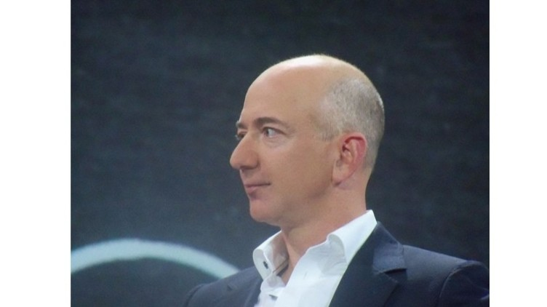](https://www.linkedin.com/pulse/aws-cloud-revolution-from-internal-project-515b-giant-girish-hukkeri-o8zde)](https://www.linkedin.com/pulse/aws-cloud-revolution-from-internal-project-515b-giant-girish-hukkeri-o8zde" \t "_self)**

**[AWS and the Cloud Revolution: From Internal Project to $51.5B Giant (2006–2021)](https://www.linkedin.com/pulse/aws-cloud-revolution-from-internal-project-515b-giant-girish-hukkeri-o8zde" \t "_self)**

[Girish Hukkeri](https://www.linkedin.com/pulse/aws-cloud-revolution-from-internal-project-515b-giant-girish-hukkeri-o8zde" \t "_self)

* 31Jabu Mkhungo and 30 others
  + 7 comments

Feed post

Published 3 weeks ago

**[[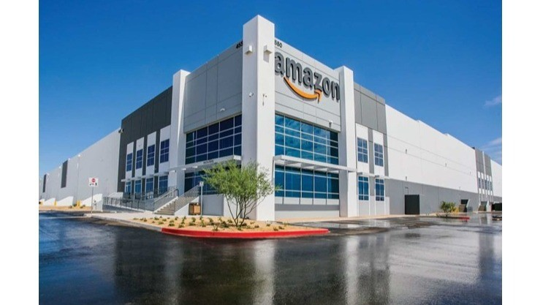](https://www.linkedin.com/pulse/amazons-global-expansion-e-commerce-dominance-20012010-girish-hukkeri-jzi1e)](https://www.linkedin.com/pulse/amazons-global-expansion-e-commerce-dominance-20012010-girish-hukkeri-jzi1e" \t "_self)**

**[Amazon's Global Expansion and E-Commerce Dominance (2001–2010): From Dot-Com Survivor to Retail Powerhouse](https://www.linkedin.com/pulse/amazons-global-expansion-e-commerce-dominance-20012010-girish-hukkeri-jzi1e" \t "_self)**

[Girish Hukkeri](https://www.linkedin.com/pulse/amazons-global-expansion-e-commerce-dominance-20012010-girish-hukkeri-jzi1e" \t "_self)

* 3Ajijia Diwa and 2 others
  + 3 comments

Feed post

Published 3 weeks ago

**[[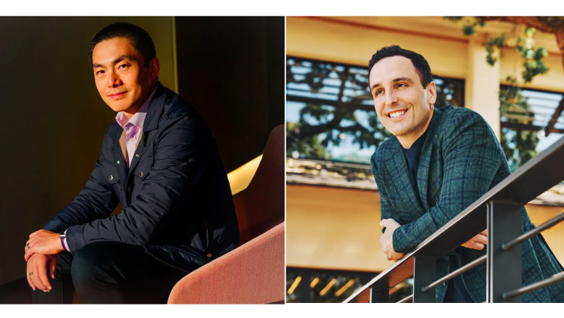](https://www.linkedin.com/pulse/new-architects-innovation-alfred-lin-pat-grady-take-helm-hukkeri-devie)](https://www.linkedin.com/pulse/new-architects-innovation-alfred-lin-pat-grady-take-helm-hukkeri-devie" \t "_self)**

**[The New Architects of Innovation: Alfred Lin and Pat Grady Take the Helm at Sequoia Capital](https://www.linkedin.com/pulse/new-architects-innovation-alfred-lin-pat-grady-take-helm-hukkeri-devie" \t "_self)**

[Girish Hukkeri](https://www.linkedin.com/pulse/new-architects-innovation-alfred-lin-pat-grady-take-helm-hukkeri-devie" \t "_self)

* 9SATISH HUKKERI and 8 others
  + 1 comment

Feed post

Published 3 weeks ago

**[[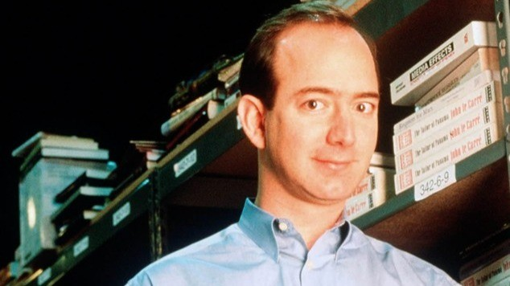](https://www.linkedin.com/pulse/jeff-bezos-early-years-struggle-build-amazon-who-bet-books-hukkeri-w7kce)](https://www.linkedin.com/pulse/jeff-bezos-early-years-struggle-build-amazon-who-bet-books-hukkeri-w7kce" \t "_self)**

**[Jeff Bezos' Early Years and the Struggle to Build Amazon: The Visionary Who Bet Everything on Books and the Internet](https://www.linkedin.com/pulse/jeff-bezos-early-years-struggle-build-amazon-who-bet-books-hukkeri-w7kce" \t "_self)**

[Girish Hukkeri](https://www.linkedin.com/pulse/jeff-bezos-early-years-struggle-build-amazon-who-bet-books-hukkeri-w7kce" \t "_self)

* 3Ajijia Diwa and 2 others

Feed post

Published 3 weeks ago

**[[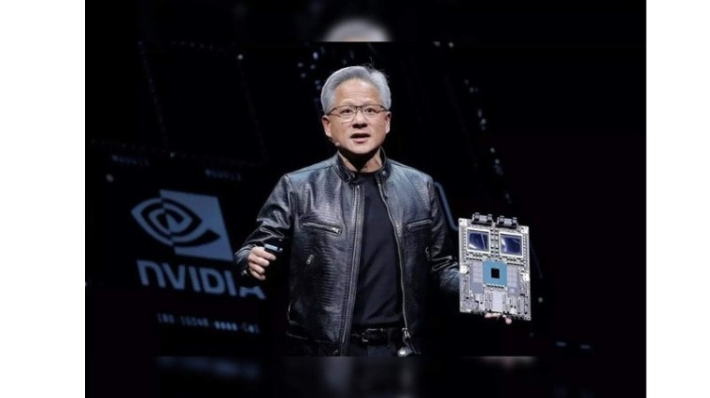](https://www.linkedin.com/pulse/nvidias-ai-era-dominance-chatgpt-catalyst-path-worlds-girish-hukkeri-tnbme)](https://www.linkedin.com/pulse/nvidias-ai-era-dominance-chatgpt-catalyst-path-worlds-girish-hukkeri-tnbme" \t "_self)**

**[Nvidia's AI Era Dominance: The ChatGPT Catalyst and the Path to the World's Most Valuable Company](https://www.linkedin.com/pulse/nvidias-ai-era-dominance-chatgpt-catalyst-path-worlds-girish-hukkeri-tnbme" \t "_self)**

[Girish Hukkeri](https://www.linkedin.com/pulse/nvidias-ai-era-dominance-chatgpt-catalyst-path-worlds-girish-hukkeri-tnbme" \t "_self)

* 9Pavan Goyal and 8 others
  + 1 comment

Feed post

Published 3 weeks ago

**[[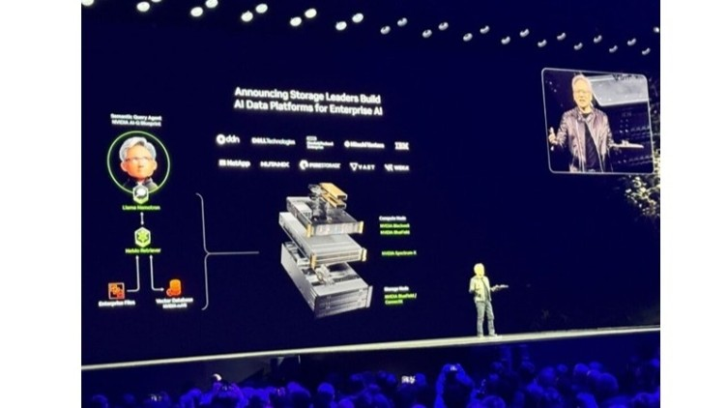](https://www.linkedin.com/pulse/nvidias-ai-foundation-from-cuda-de-facto-standard-before-hukkeri-fqhve)](https://www.linkedin.com/pulse/nvidias-ai-foundation-from-cuda-de-facto-standard-before-hukkeri-fqhve" \t "_self)**

**[Nvidia's AI Foundation: From CUDA to the De Facto Standard Before ChatGPT](https://www.linkedin.com/pulse/nvidias-ai-foundation-from-cuda-de-facto-standard-before-hukkeri-fqhve" \t "_self)**

[Girish Hukkeri](https://www.linkedin.com/pulse/nvidias-ai-foundation-from-cuda-de-facto-standard-before-hukkeri-fqhve" \t "_self)

* 4Claudia Drummond and 3 others
  + 2 comments

Feed post

Published 3 weeks ago

**[[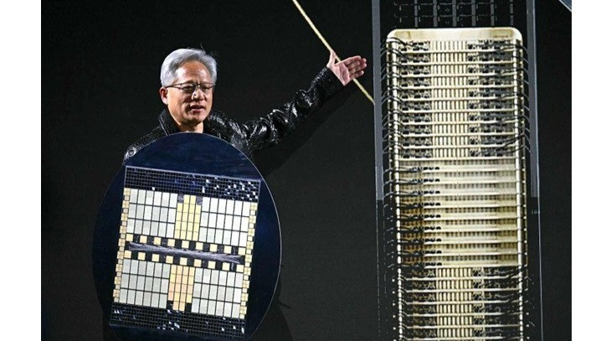](https://www.linkedin.com/pulse/nvidias-gaming-dominance-geforce-revolution-rise-gpu-girish-hukkeri-vegwe)](https://www.linkedin.com/pulse/nvidias-gaming-dominance-geforce-revolution-rise-gpu-girish-hukkeri-vegwe" \t "_self)**

**[Nvidia's Gaming Dominance: The GeForce Revolution and the Rise of GPU Leadership](https://www.linkedin.com/pulse/nvidias-gaming-dominance-geforce-revolution-rise-gpu-girish-hukkeri-vegwe" \t "_self)**

[Girish Hukkeri](https://www.linkedin.com/pulse/nvidias-gaming-dominance-geforce-revolution-rise-gpu-girish-hukkeri-vegwe" \t "_self)

* 9Pavan Goyal and 8 others

Feed post

Published 3 weeks ago

**[[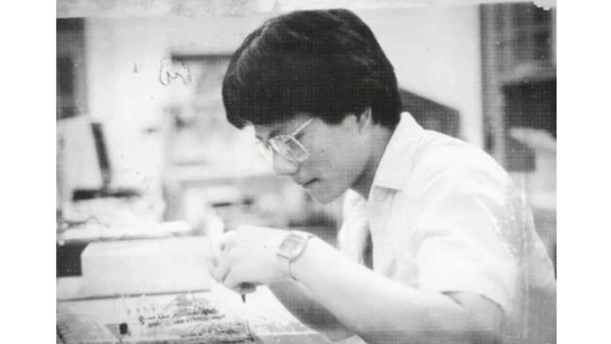](https://www.linkedin.com/pulse/jensen-huangs-gpu-vision-from-immigrant-dishwasher-silicon-hukkeri-jsyqe)](https://www.linkedin.com/pulse/jensen-huangs-gpu-vision-from-immigrant-dishwasher-silicon-hukkeri-jsyqe" \t "_self)**

**[Jensen Huang's GPU Vision: From Immigrant Dishwasher to Silicon Valley Visionary, The Founding and Survival of Nvidia](https://www.linkedin.com/pulse/jensen-huangs-gpu-vision-from-immigrant-dishwasher-silicon-hukkeri-jsyqe" \t "_self)**

[Girish Hukkeri](https://www.linkedin.com/pulse/jensen-huangs-gpu-vision-from-immigrant-dishwasher-silicon-hukkeri-jsyqe" \t "_self)

* 9Kaushik Naarayan and 8 others

Feed post

Published 3 weeks ago

**[[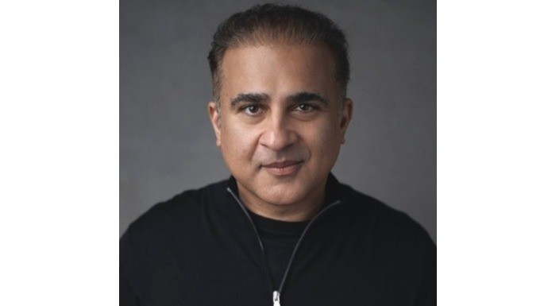](https://www.linkedin.com/pulse/dr-vik-bajaj-moonshot-architect-behind-project-girish-hukkeri-bkjie)](https://www.linkedin.com/pulse/dr-vik-bajaj-moonshot-architect-behind-project-girish-hukkeri-bkjie" \t "_self)**

**[Dr. Vik Bajaj: The Moonshot Architect Behind Project Prometheus](https://www.linkedin.com/pulse/dr-vik-bajaj-moonshot-architect-behind-project-girish-hukkeri-bkjie" \t "_self)**

[Girish Hukkeri](https://www.linkedin.com/pulse/dr-vik-bajaj-moonshot-architect-behind-project-girish-hukkeri-bkjie" \t "_self)

* 14Pavan Goyal and 13 others
  + 7 comments

Feed post

Published 3 weeks ago

**[[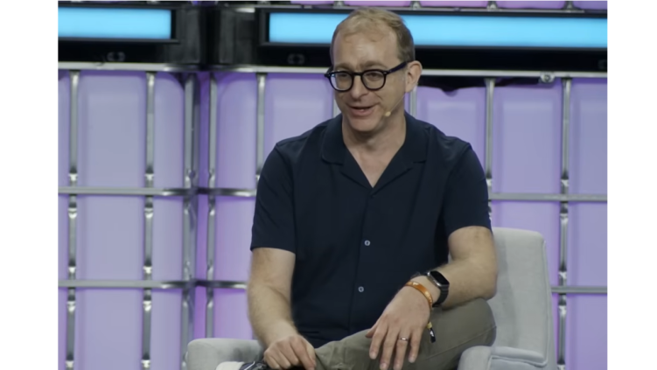](https://www.linkedin.com/pulse/avery-pennarun-tailscale-engineering-new-internet-through-hukkeri-nblxe)](https://www.linkedin.com/pulse/avery-pennarun-tailscale-engineering-new-internet-through-hukkeri-nblxe" \t "_self)**

**[Avery Pennarun & Tailscale: Engineering the New Internet Through Authenticity and Innovation](https://www.linkedin.com/pulse/avery-pennarun-tailscale-engineering-new-internet-through-hukkeri-nblxe" \t "_self)**

[Girish Hukkeri](https://www.linkedin.com/pulse/avery-pennarun-tailscale-engineering-new-internet-through-hukkeri-nblxe" \t "_self)

* 11MUH MASRI SARI and 10 others
  + 2 comments

Feed post

Published 3 weeks ago

**[[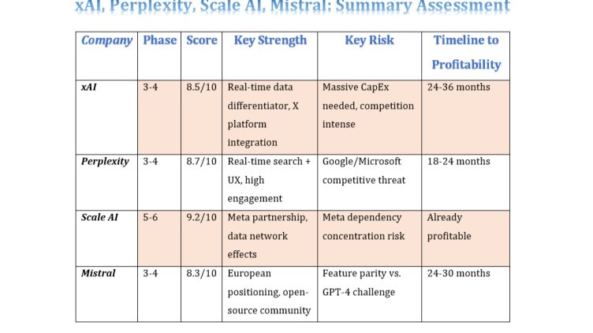](https://www.linkedin.com/pulse/applied-analysis-8-ai-unicorns-girish-hukkeri-1zwbf)](https://www.linkedin.com/pulse/applied-analysis-8-ai-unicorns-girish-hukkeri-1zwbf" \t "_self)**

**[Applied Analysis of 8 AI Unicorns](https://www.linkedin.com/pulse/applied-analysis-8-ai-unicorns-girish-hukkeri-1zwbf" \t "_self)**

[Girish Hukkeri](https://www.linkedin.com/pulse/applied-analysis-8-ai-unicorns-girish-hukkeri-1zwbf" \t "_self)

* 4Ajijia Diwa and 3 others

Feed post

Published 3 weeks ago

**[[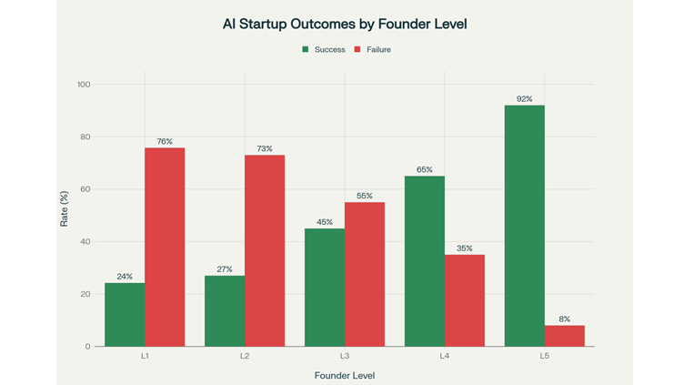](https://www.linkedin.com/pulse/ai-startup-ecosystem-bifurcates-winners-losers-new-era-girish-hukkeri-94oje)](https://www.linkedin.com/pulse/ai-startup-ecosystem-bifurcates-winners-losers-new-era-girish-hukkeri-94oje" \t "_self)**

**[The AI Startup Ecosystem Bifurcates: Winners and Losers in the New Era](https://www.linkedin.com/pulse/ai-startup-ecosystem-bifurcates-winners-losers-new-era-girish-hukkeri-94oje" \t "_self)**

[Girish Hukkeri](https://www.linkedin.com/pulse/ai-startup-ecosystem-bifurcates-winners-losers-new-era-girish-hukkeri-94oje" \t "_self)

* 7Kaushik Naarayan and 6 others
  + 2 comments

Feed post

Published 1 month ago

**[[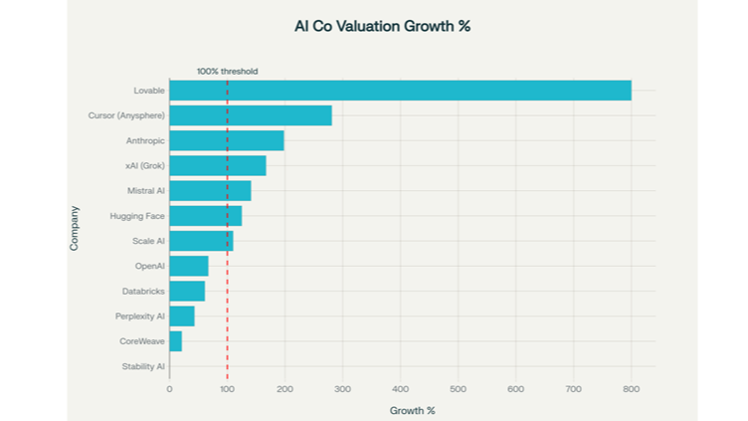](https://www.linkedin.com/pulse/ai-performance-paradox-how-market-leaders-exceeding-while-hukkeri-ygvqe)](https://www.linkedin.com/pulse/ai-performance-paradox-how-market-leaders-exceeding-while-hukkeri-ygvqe" \t "_self)**

**[The AI Performance Paradox: How Market Leaders Are Dramatically Exceeding Projections While the "Bubble Burst" Narrative Persists](https://www.linkedin.com/pulse/ai-performance-paradox-how-market-leaders-exceeding-while-hukkeri-ygvqe" \t "_self)**

[Girish Hukkeri](https://www.linkedin.com/pulse/ai-performance-paradox-how-market-leaders-exceeding-while-hukkeri-ygvqe" \t "_self)

* 6Pavan Goyal and 5 others
  + 1 comment

Feed post

Published 1 month ago

**[[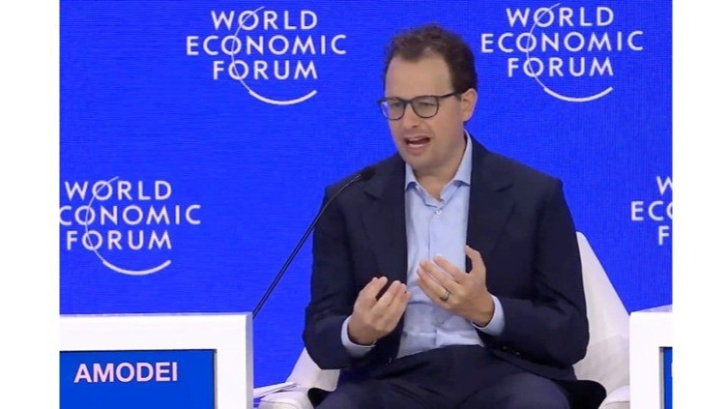](https://www.linkedin.com/pulse/amodei-ascendancy-how-two-siblings-steered-anthropic-from-hukkeri-3lu5e)](https://www.linkedin.com/pulse/amodei-ascendancy-how-two-siblings-steered-anthropic-from-hukkeri-3lu5e" \t "_self)**

**[The Amodei Ascendancy: How Two Siblings Steered Anthropic from $183B to a Potential $350B Giant](https://www.linkedin.com/pulse/amodei-ascendancy-how-two-siblings-steered-anthropic-from-hukkeri-3lu5e" \t "_self)**

[Girish Hukkeri](https://www.linkedin.com/pulse/amodei-ascendancy-how-two-siblings-steered-anthropic-from-hukkeri-3lu5e" \t "_self)

* 1

Feed post

Published 1 month ago

**[[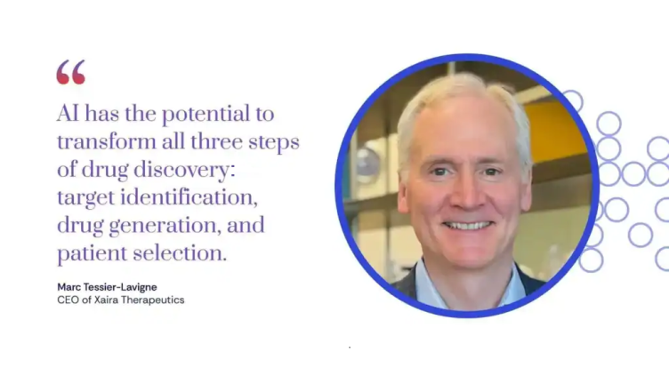](https://www.linkedin.com/pulse/marc-tessier-lavigne-david-baker-visionaries-drug-xaira-hukkeri-n6vte)](https://www.linkedin.com/pulse/marc-tessier-lavigne-david-baker-visionaries-drug-xaira-hukkeri-n6vte" \t "_self)**

**[Marc Tessier-Lavigne and David Baker: The Visionaries Reshaping Drug Discovery at Xaira Therapeutics](https://www.linkedin.com/pulse/marc-tessier-lavigne-david-baker-visionaries-drug-xaira-hukkeri-n6vte" \t "_self)**

[Girish Hukkeri](https://www.linkedin.com/pulse/marc-tessier-lavigne-david-baker-visionaries-drug-xaira-hukkeri-n6vte" \t "_self)

* 4Radhe Mishra and 3 others

Feed post

Published 1 month ago

**[[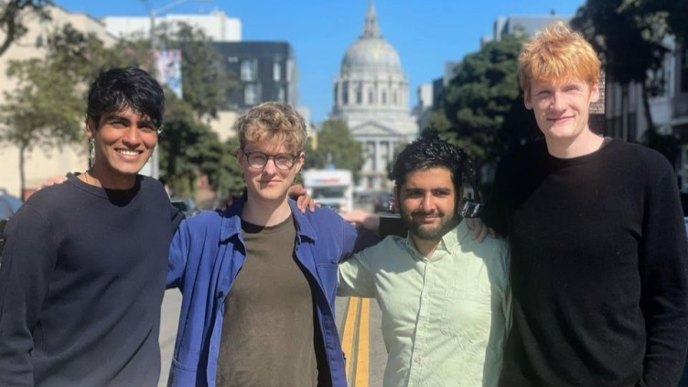](https://www.linkedin.com/pulse/visionary-quartet-behind-cursor-how-four-mit-students-girish-hukkeri-eweye)](https://www.linkedin.com/pulse/visionary-quartet-behind-cursor-how-four-mit-students-girish-hukkeri-eweye" \t "_self)**

**[The Visionary Quartet Behind Cursor: How Four MIT Students Built a $29.3 Billion AI Empire](https://www.linkedin.com/pulse/visionary-quartet-behind-cursor-how-four-mit-students-girish-hukkeri-eweye" \t "_self)**

[Girish Hukkeri](https://www.linkedin.com/pulse/visionary-quartet-behind-cursor-how-four-mit-students-girish-hukkeri-eweye" \t "_self)

* 7Hrishikesh Hukkeri and 6 others
  + 3 comments

Feed post

Published 1 month ago

**[[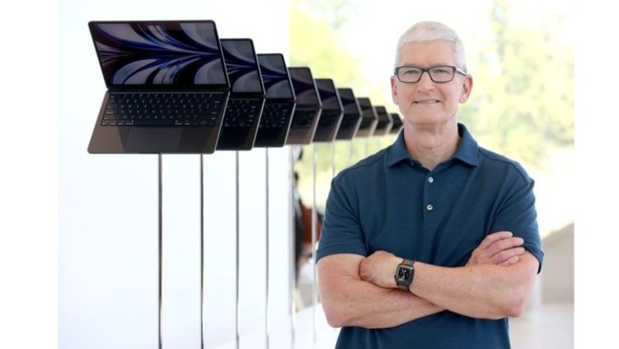](https://www.linkedin.com/pulse/apple-after-steve-jobs-legacy-sustained-vision-expanded-hukkeri-pciqe)](https://www.linkedin.com/pulse/apple-after-steve-jobs-legacy-sustained-vision-expanded-hukkeri-pciqe" \t "_self)**

**[Apple After Steve Jobs: A Legacy Sustained, A Vision Expanded, and a Company Transformed](https://www.linkedin.com/pulse/apple-after-steve-jobs-legacy-sustained-vision-expanded-hukkeri-pciqe" \t "_self)**

[Girish Hukkeri](https://www.linkedin.com/pulse/apple-after-steve-jobs-legacy-sustained-vision-expanded-hukkeri-pciqe" \t "_self)

* 12Pavan Goyal and 11 others
  + 4 comments

Feed post

Published 1 month ago

**[[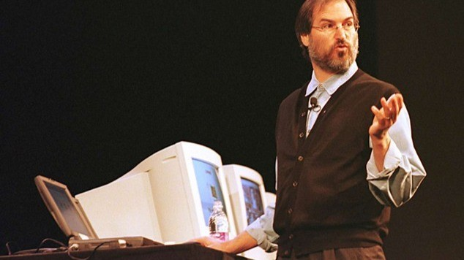](https://www.linkedin.com/pulse/steve-jobs-phoenix-returns-apples-resurrection-legacy-girish-hukkeri-ajyye)](https://www.linkedin.com/pulse/steve-jobs-phoenix-returns-apples-resurrection-legacy-girish-hukkeri-ajyye" \t "_self)**

**[Steve Jobs: The Phoenix Returns: Apple's Resurrection and a Legacy Sealed in Innovation](https://www.linkedin.com/pulse/steve-jobs-phoenix-returns-apples-resurrection-legacy-girish-hukkeri-ajyye" \t "_self)**

[Girish Hukkeri](https://www.linkedin.com/pulse/steve-jobs-phoenix-returns-apples-resurrection-legacy-girish-hukkeri-ajyye" \t "_self)

* 10Radhe Mishra and 9 others
  + 3 comments

Feed post

Published 1 month ago

**[[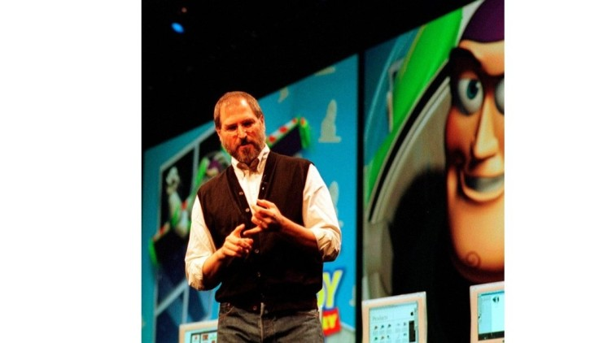](https://www.linkedin.com/pulse/steve-jobs-pixar-disney-renaissance-animation-years-between-hukkeri-zpgwe)](https://www.linkedin.com/pulse/steve-jobs-pixar-disney-renaissance-animation-years-between-hukkeri-zpgwe" \t "_self)**

**[Steve Jobs: Pixar, Disney, and the Renaissance of Animation, The Visionary Years Between Exile and Return](https://www.linkedin.com/pulse/steve-jobs-pixar-disney-renaissance-animation-years-between-hukkeri-zpgwe" \t "_self)**

[Girish Hukkeri](https://www.linkedin.com/pulse/steve-jobs-pixar-disney-renaissance-animation-years-between-hukkeri-zpgwe" \t "_self)

* 6Munir Machmud Ali and 5 others

Feed post

Published 1 month ago

**[[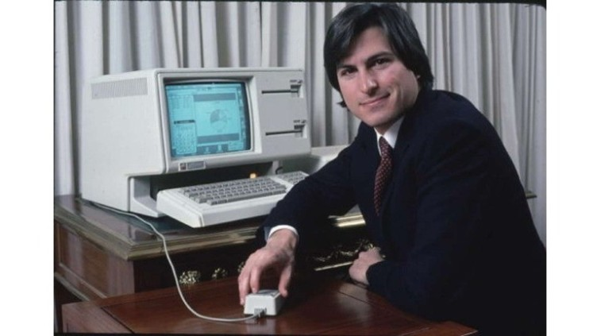](https://www.linkedin.com/pulse/steve-jobs-from-garage-dreams-expulsion-genesis-exodus-girish-hukkeri-ozene)](https://www.linkedin.com/pulse/steve-jobs-from-garage-dreams-expulsion-genesis-exodus-girish-hukkeri-ozene" \t "_self)**

**[Steve Jobs: From Garage Dreams to Expulsion, the Genesis and Exodus of Apple's Revolutionary Founder](https://www.linkedin.com/pulse/steve-jobs-from-garage-dreams-expulsion-genesis-exodus-girish-hukkeri-ozene" \t "_self)**

[Girish Hukkeri](https://www.linkedin.com/pulse/steve-jobs-from-garage-dreams-expulsion-genesis-exodus-girish-hukkeri-ozene" \t "_self)

* 6Vishwanath Sangoji and 5 others
  + 1 comment

Feed post

Published 1 month ago

**[[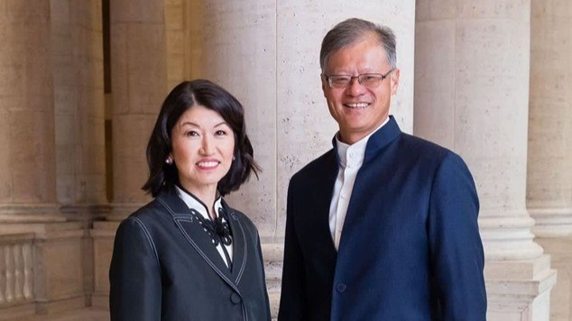](https://www.linkedin.com/pulse/jerry-yang-from-yahoo-pioneer-silicon-valley-girish-hukkeri-vwnhe)](https://www.linkedin.com/pulse/jerry-yang-from-yahoo-pioneer-silicon-valley-girish-hukkeri-vwnhe" \t "_self)**

**[Jerry Yang: From Yahoo! Pioneer to Silicon Valley Statesman](https://www.linkedin.com/pulse/jerry-yang-from-yahoo-pioneer-silicon-valley-girish-hukkeri-vwnhe" \t "_self)**

[Girish Hukkeri](https://www.linkedin.com/pulse/jerry-yang-from-yahoo-pioneer-silicon-valley-girish-hukkeri-vwnhe" \t "_self)

* 23Filadelfia RAKOTOMALALA ALIJAONA and 22 others
  + 5 comments

Feed post

Published 1 month ago

**[[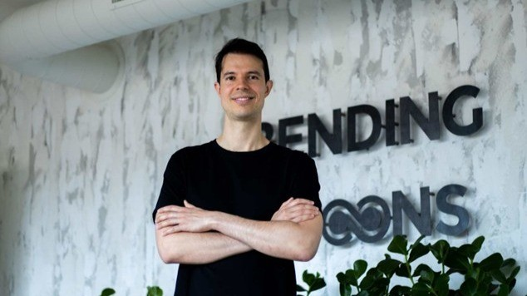](https://www.linkedin.com/pulse/architect-digital-transformation-luca-ferraris-building-hukkeri-x2ace)](https://www.linkedin.com/pulse/architect-digital-transformation-luca-ferraris-building-hukkeri-x2ace" \t "_self)**

**[The Architect of Digital Transformation: Luca Ferrari's Blueprint for Building an All-Time Great Company](https://www.linkedin.com/pulse/architect-digital-transformation-luca-ferraris-building-hukkeri-x2ace" \t "_self)**

[Girish Hukkeri](https://www.linkedin.com/pulse/architect-digital-transformation-luca-ferraris-building-hukkeri-x2ace" \t "_self)

* 5Munir Machmud Ali and 4 others
  + 1 comment

Feed post

Published 1 month ago

**[[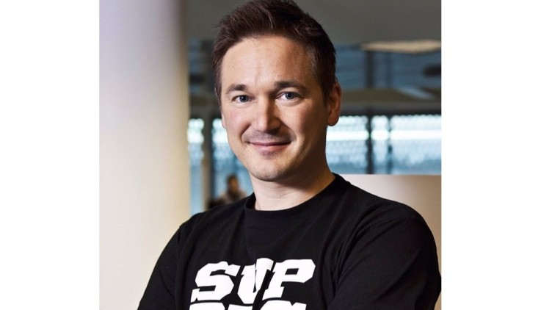](https://www.linkedin.com/pulse/ilkka-paananen-architect-forever-games-girish-hukkeri-jr6me)](https://www.linkedin.com/pulse/ilkka-paananen-architect-forever-games-girish-hukkeri-jr6me" \t "_self)**

**[Ilkka Paananen: The Architect of Forever Games](https://www.linkedin.com/pulse/ilkka-paananen-architect-forever-games-girish-hukkeri-jr6me" \t "_self)**

[Girish Hukkeri](https://www.linkedin.com/pulse/ilkka-paananen-architect-forever-games-girish-hukkeri-jr6me" \t "_self)

* 3Pavan Goyal and 2 others
  + 1 comment

Feed post

Published 1 month ago

**[[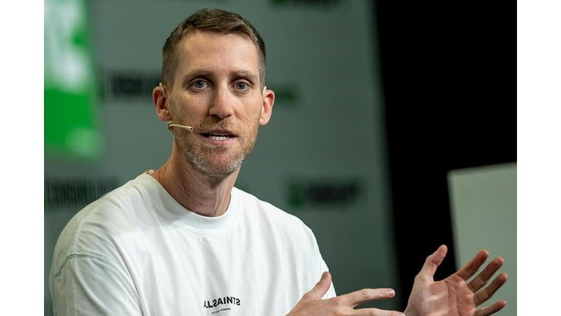](https://www.linkedin.com/pulse/assaf-rappaport-architect-cloud-securitys-fastest-unicorn-hukkeri-83tne)](https://www.linkedin.com/pulse/assaf-rappaport-architect-cloud-securitys-fastest-unicorn-hukkeri-83tne" \t "_self)**

**[Assaf Rappaport: The Architect of Cloud Security's Fastest Unicorn](https://www.linkedin.com/pulse/assaf-rappaport-architect-cloud-securitys-fastest-unicorn-hukkeri-83tne" \t "_self)**

[Girish Hukkeri](https://www.linkedin.com/pulse/assaf-rappaport-architect-cloud-securitys-fastest-unicorn-hukkeri-83tne" \t "_self)

* 8Amoni Finau and 7 others
  + 3 comments

Feed post

Published 1 month ago

**[[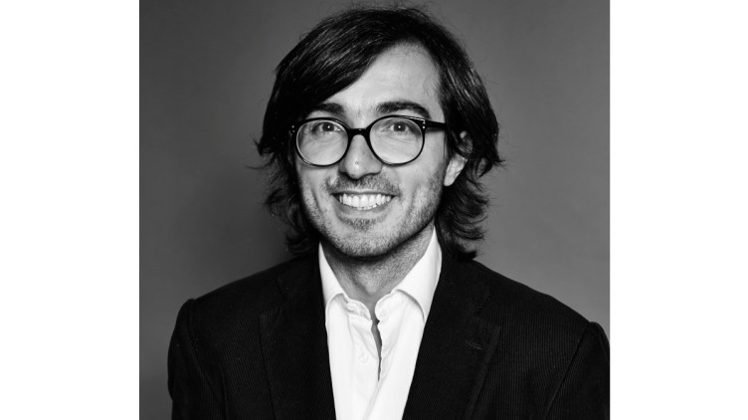](https://www.linkedin.com/pulse/efe-cakarel-mubi-curating-cinema-age-algorithms-girish-hukkeri-a747e)](https://www.linkedin.com/pulse/efe-cakarel-mubi-curating-cinema-age-algorithms-girish-hukkeri-a747e" \t "_self)**

**[Efe Cakarel of MUBI: Curating Cinema in the Age of Algorithms](https://www.linkedin.com/pulse/efe-cakarel-mubi-curating-cinema-age-algorithms-girish-hukkeri-a747e" \t "_self)**

[Girish Hukkeri](https://www.linkedin.com/pulse/efe-cakarel-mubi-curating-cinema-age-algorithms-girish-hukkeri-a747e" \t "_self)

* 9Pavan Goyal and 8 others
  + 3 comments

Feed post

Published 1 month ago

**[[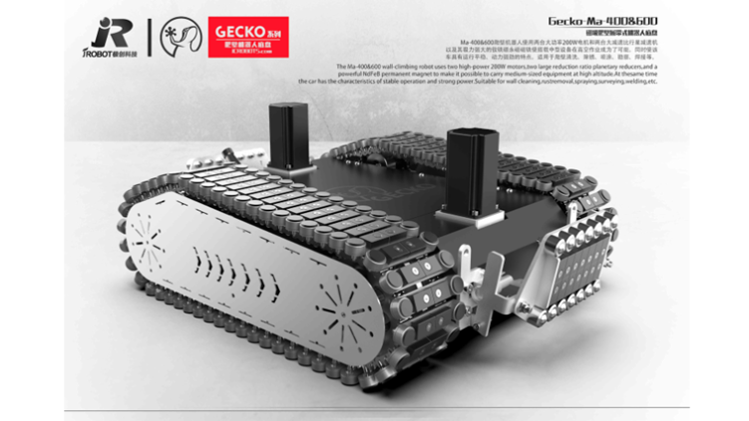](https://www.linkedin.com/pulse/jake-loosararian-resilient-visionary-building-girish-hukkeri-tmtfe)](https://www.linkedin.com/pulse/jake-loosararian-resilient-visionary-building-girish-hukkeri-tmtfe" \t "_self)**

**[Jake Loosararian: The Resilient Visionary Building Tomorrow's Infrastructure Intelligence](https://www.linkedin.com/pulse/jake-loosararian-resilient-visionary-building-girish-hukkeri-tmtfe" \t "_self)**

[Girish Hukkeri](https://www.linkedin.com/pulse/jake-loosararian-resilient-visionary-building-girish-hukkeri-tmtfe" \t "_self)

* 8Munir Machmud Ali and 7 others
  + 1 comment

Feed post

Published 1 month ago

**[[](https://www.linkedin.com/pulse/shalev-hulio-dream-from-offensive-cyber-operations-national-hukkeri-zujue)](https://www.linkedin.com/pulse/shalev-hulio-dream-from-offensive-cyber-operations-national-hukkeri-zujue" \t "_self)**

**[Shalev Hulio & Dream: From Offensive Cyber Operations to National Defense Strategy](https://www.linkedin.com/pulse/shalev-hulio-dream-from-offensive-cyber-operations-national-hukkeri-zujue" \t "_self)**

[Girish Hukkeri](https://www.linkedin.com/pulse/shalev-hulio-dream-from-offensive-cyber-operations-national-hukkeri-zujue" \t "_self)

* 9Pavan Goyal and 8 others
  + 3 comments

Feed post

Published 1 month ago

**[[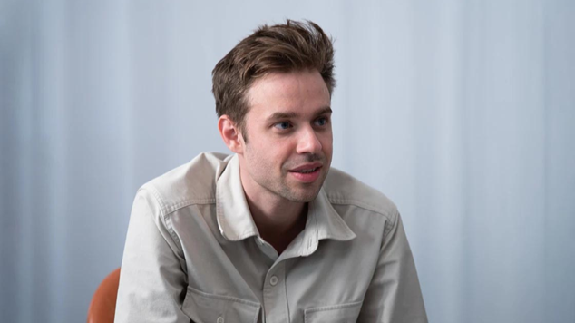](https://www.linkedin.com/pulse/anton-osika-swedish-physicist-democratizing-software-creation-girish-fy6ve)](https://www.linkedin.com/pulse/anton-osika-swedish-physicist-democratizing-software-creation-girish-fy6ve" \t "_self)**

**[Anton Osika: The Swedish Physicist Democratizing Software Creation Through Lovable](https://www.linkedin.com/pulse/anton-osika-swedish-physicist-democratizing-software-creation-girish-fy6ve" \t "_self)**

[Girish Hukkeri](https://www.linkedin.com/pulse/anton-osika-swedish-physicist-democratizing-software-creation-girish-fy6ve" \t "_self)

* 1

Feed post

Published 1 month ago

**[[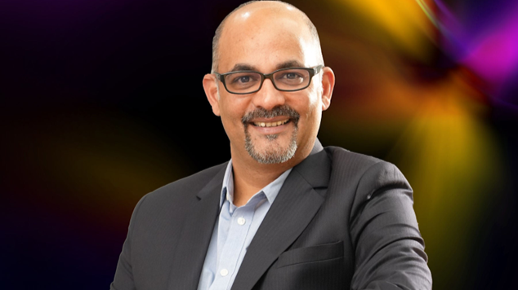](https://www.linkedin.com/pulse/sameer-nigam-architect-indias-digital-payments-girish-hukkeri-i7v0e)](https://www.linkedin.com/pulse/sameer-nigam-architect-indias-digital-payments-girish-hukkeri-i7v0e" \t "_self)**

**[Sameer Nigam: The Architect of India's Digital Payments Revolution](https://www.linkedin.com/pulse/sameer-nigam-architect-indias-digital-payments-girish-hukkeri-i7v0e" \t "_self)**

[Girish Hukkeri](https://www.linkedin.com/pulse/sameer-nigam-architect-indias-digital-payments-girish-hukkeri-i7v0e" \t "_self)

* 3Radhe Mishra and 2 others

Feed post

Published 1 month ago

**[[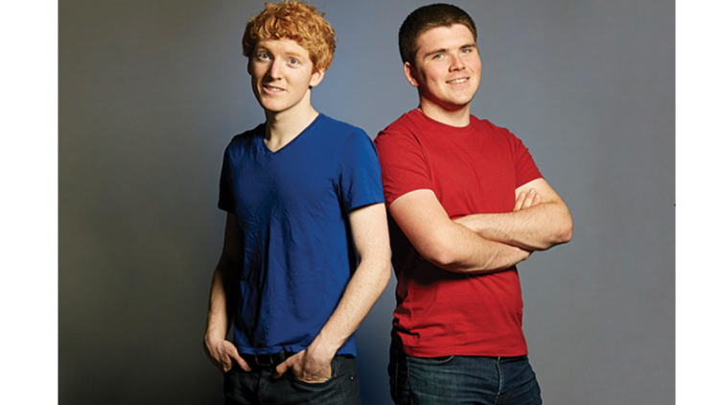](https://www.linkedin.com/pulse/collison-brothers-building-economic-infrastructure-internet-hukkeri-9y2le)](https://www.linkedin.com/pulse/collison-brothers-building-economic-infrastructure-internet-hukkeri-9y2le" \t "_self)**

**[The Collison Brothers: Building the Economic Infrastructure of the Internet](https://www.linkedin.com/pulse/collison-brothers-building-economic-infrastructure-internet-hukkeri-9y2le" \t "_self)**

[Girish Hukkeri](https://www.linkedin.com/pulse/collison-brothers-building-economic-infrastructure-internet-hukkeri-9y2le" \t "_self)

* 7Kaushik Naarayan and 6 others
  + 3 comments

Feed post

Published 1 month ago

**[[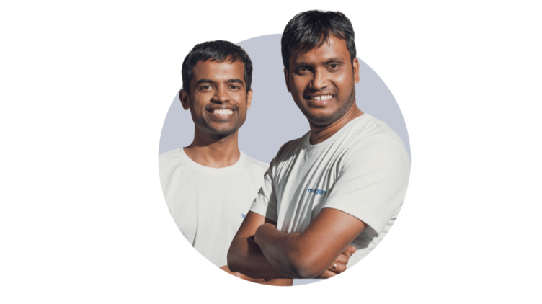](https://www.linkedin.com/pulse/moengage-crafting-future-ai-powered-customer-through-girish-hukkeri-rgq9e)](https://www.linkedin.com/pulse/moengage-crafting-future-ai-powered-customer-through-girish-hukkeri-rgq9e" \t "_self)**

**[MoEngage: Crafting the Future of AI-Powered Customer Engagement Through Innovation and Visionary Leadership](https://www.linkedin.com/pulse/moengage-crafting-future-ai-powered-customer-through-girish-hukkeri-rgq9e" \t "_self)**

[Girish Hukkeri](https://www.linkedin.com/pulse/moengage-crafting-future-ai-powered-customer-through-girish-hukkeri-rgq9e" \t "_self)

* 19Pavan Goyal and 18 others
  + 5 comments

Feed post

Published 1 month ago

**[[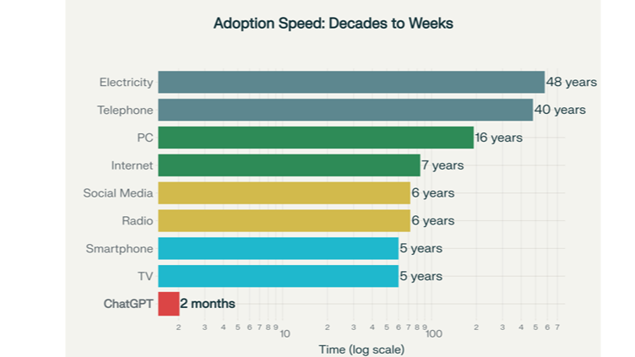](https://www.linkedin.com/pulse/ai-bubble-burst-why-instant-diffusion-makes-girish-hukkeri-iwwwe)](https://www.linkedin.com/pulse/ai-bubble-burst-why-instant-diffusion-makes-girish-hukkeri-iwwwe" \t "_self)**

**[AI Bubble Burst : Why Instant Diffusion Makes It Irrelevant](https://www.linkedin.com/pulse/ai-bubble-burst-why-instant-diffusion-makes-girish-hukkeri-iwwwe" \t "_self)**

[Girish Hukkeri](https://www.linkedin.com/pulse/ai-bubble-burst-why-instant-diffusion-makes-girish-hukkeri-iwwwe" \t "_self)

* 6Mohammed Alomar and 5 others
  + 2 comments

Feed post

Published 1 month ago

**[[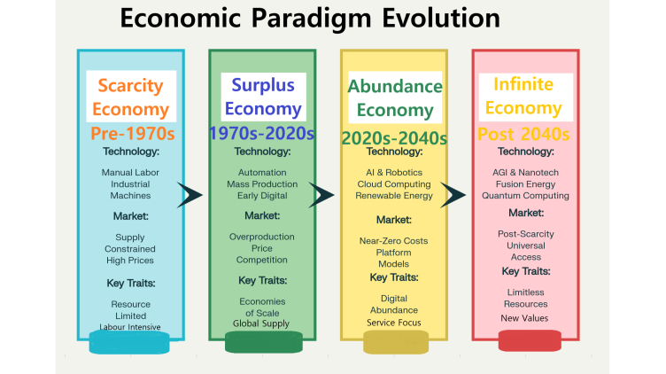](https://www.linkedin.com/pulse/christensens-enduring-wisdom-leveraging-disruptive-theory-hukkeri-exhde)](https://www.linkedin.com/pulse/christensens-enduring-wisdom-leveraging-disruptive-theory-hukkeri-exhde" \t "_self)**

**[Christensen's Enduring Wisdom: Leveraging Disruptive Innovation Theory for the Journey to Unicorn Status and Beyond](https://www.linkedin.com/pulse/christensens-enduring-wisdom-leveraging-disruptive-theory-hukkeri-exhde" \t "_self)**

[Girish Hukkeri](https://www.linkedin.com/pulse/christensens-enduring-wisdom-leveraging-disruptive-theory-hukkeri-exhde" \t "_self)

* 3Trevor Dawson and 2 others

Feed post

Published 1 month ago

**[[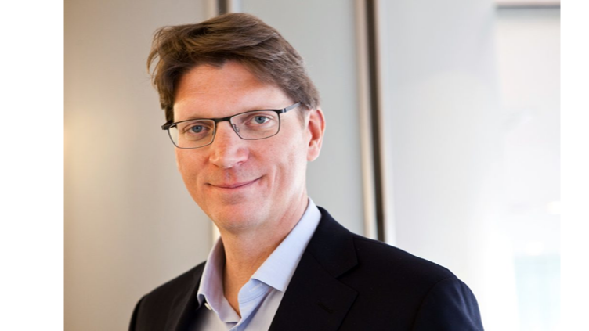](https://www.linkedin.com/pulse/niklas-zennstr%C3%B6m-visionary-who-connected-world-european-hukkeri-7n86e)](https://www.linkedin.com/pulse/niklas-zennstr%C3%B6m-visionary-who-connected-world-european-hukkeri-7n86e" \t "_self)**

**[Niklas Zennström: The Visionary Who Connected the World and Revolutionized European Tech](https://www.linkedin.com/pulse/niklas-zennstr%C3%B6m-visionary-who-connected-world-european-hukkeri-7n86e" \t "_self)**

[Girish Hukkeri](https://www.linkedin.com/pulse/niklas-zennstr%C3%B6m-visionary-who-connected-world-european-hukkeri-7n86e" \t "_self)

* 9SATISH HUKKERI and 8 others
  + 1 comment

Show more results

* [About](https://about.linkedin.com/)
* [Accessibility](https://www.linkedin.com/accessibility)
* [Help Center](https://www.linkedin.com/help/linkedin?trk=footer_d_flagship3_series_entity)
* Privacy & Terms
* [Ad Choices](https://www.linkedin.com/help/linkedin/answer/62931)
* [Advertising](https://www.linkedin.com/ad/start?trk=n_nav_ads_rr)
* Business Services
* Get the LinkedIn app
* More